|  |  |  |
| --- | --- | --- |
| Лабораторная работа №4  Запросы | Ф.И.О. | Синкевич Д. А. |
| Группа | ПРИН-366 |
| Преподаватель | Соколов А.А. |
| Дата сдачи |  |

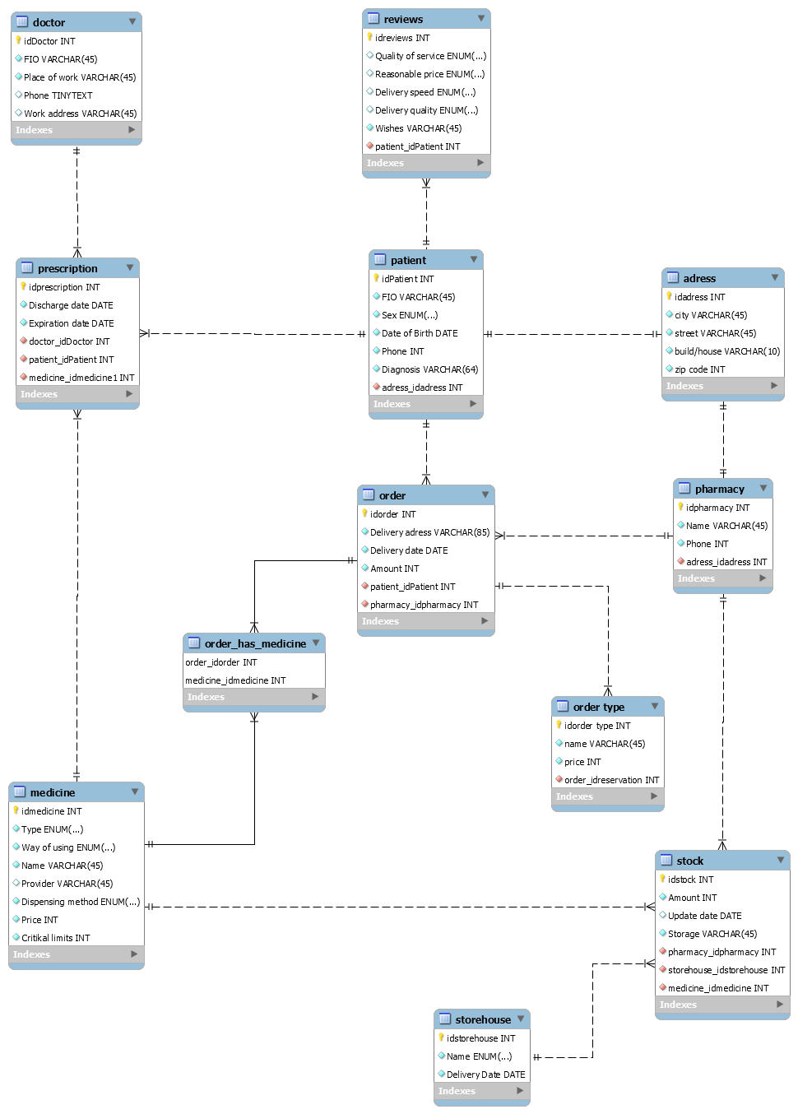

1. Реляционная модель

Запросы, которые вы указали в функциональных требованиях (комментарием указать, что за требование):

Транзакционные:

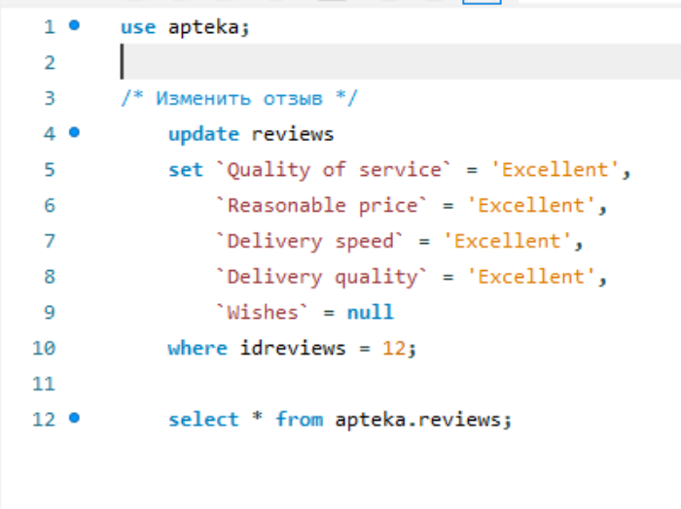 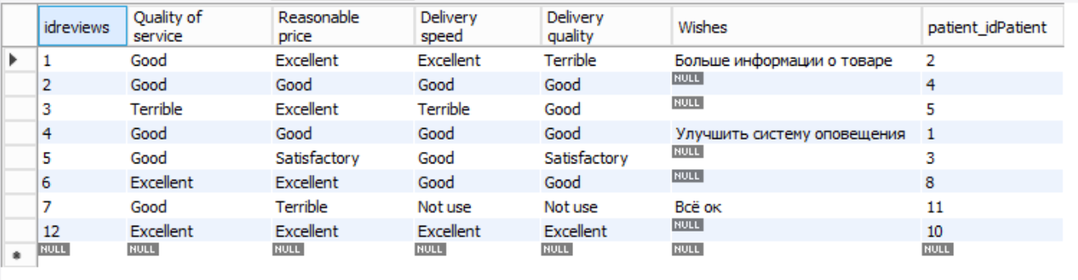

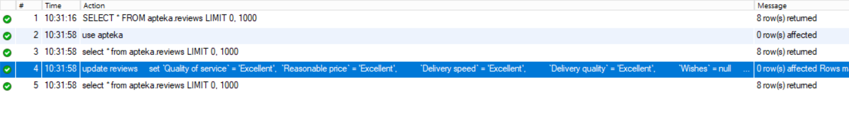

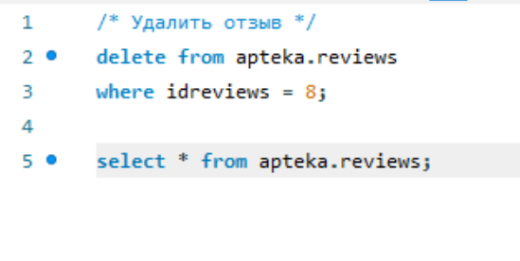

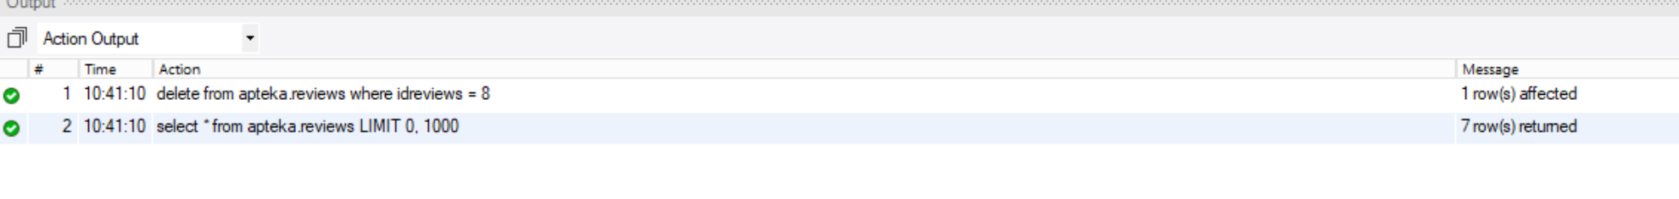

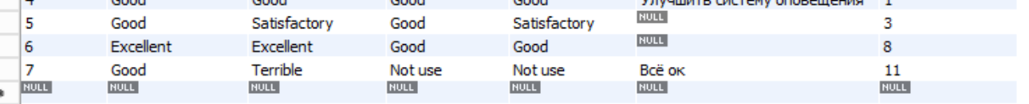

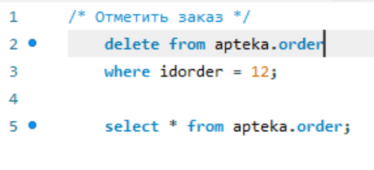





4)

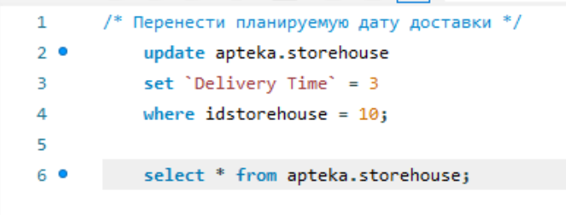



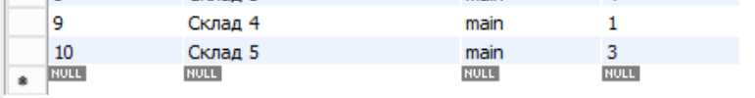

5)

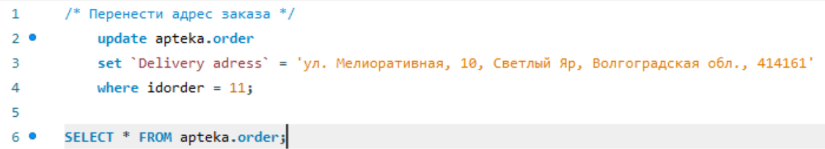





Справочные (оперативные запросы):

6)

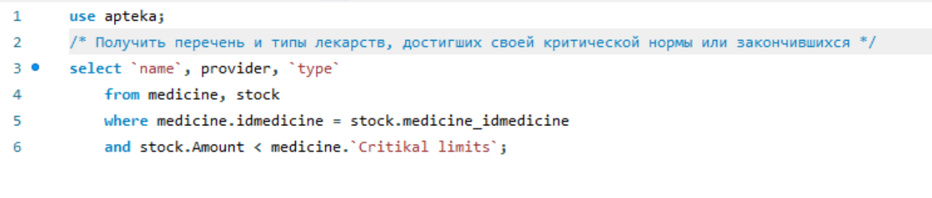



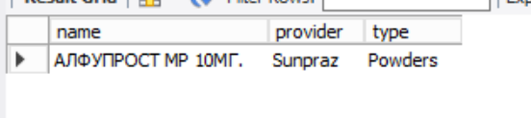

7)

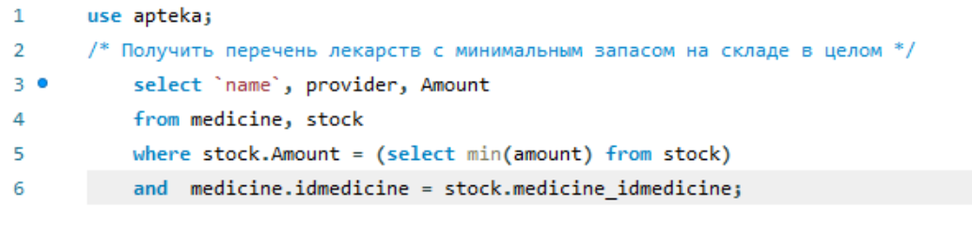



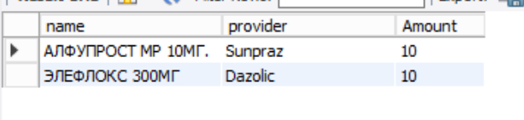

8)

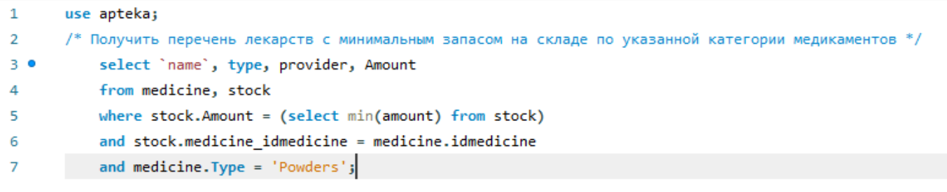



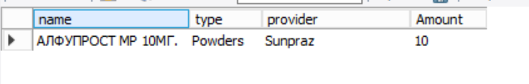

9)

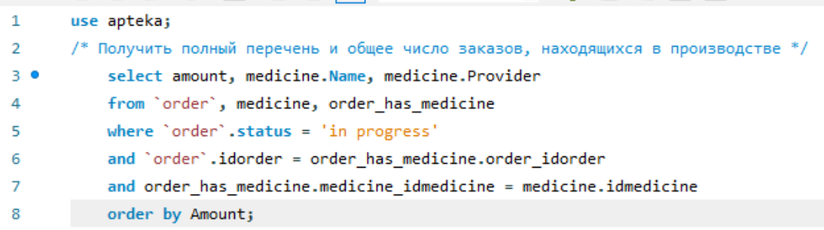



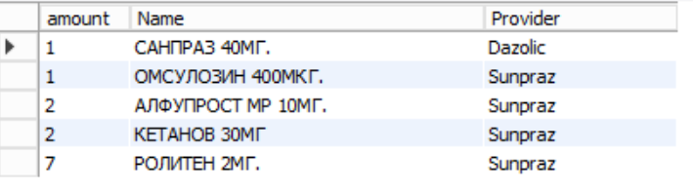

10)

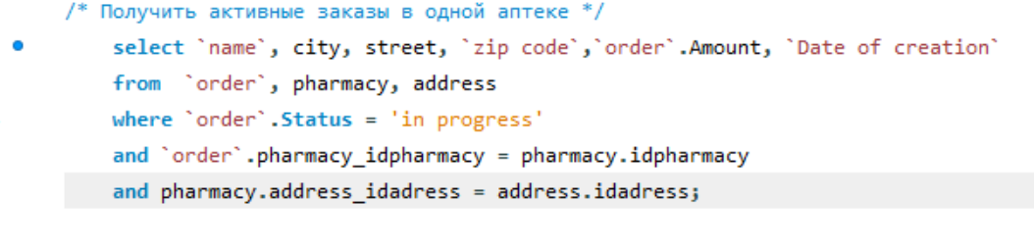



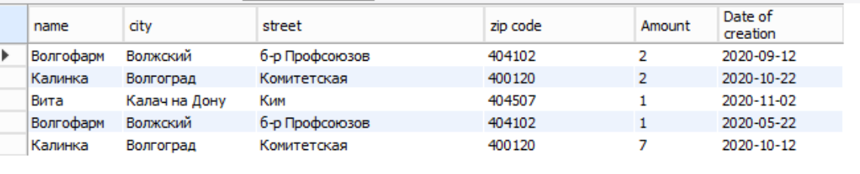

11) ????

12)

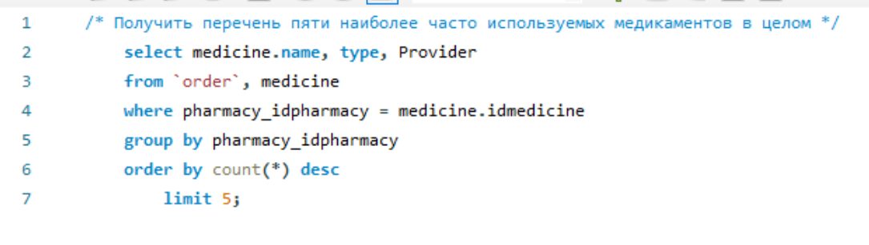



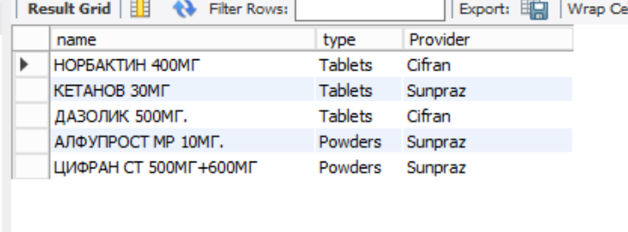

13)

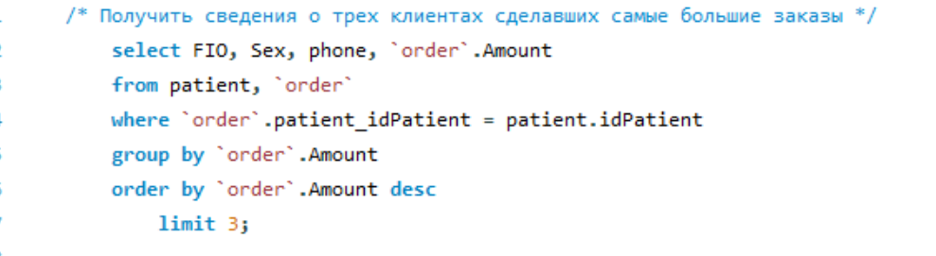



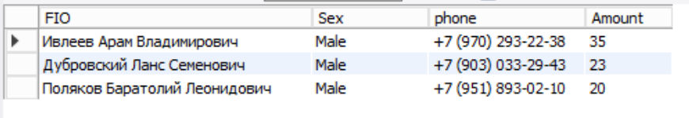

14)

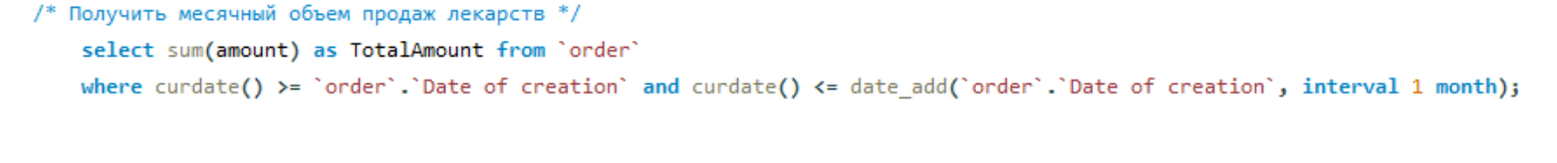



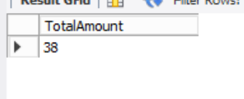

15)

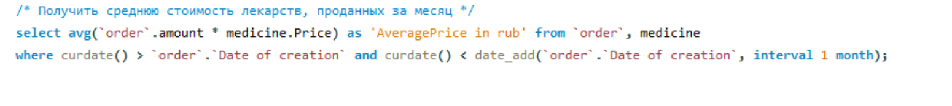



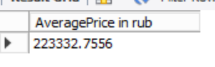

Запросы Insert

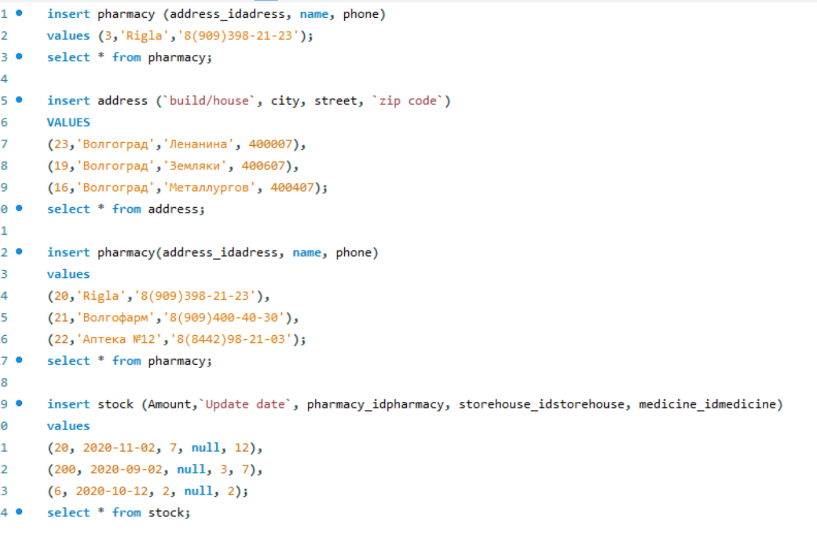

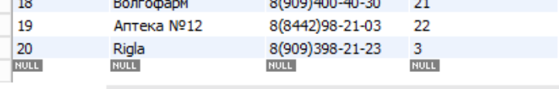

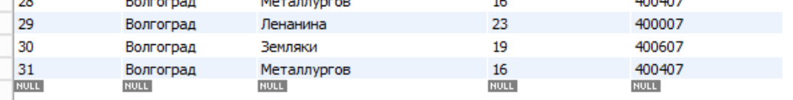

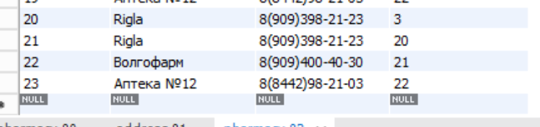

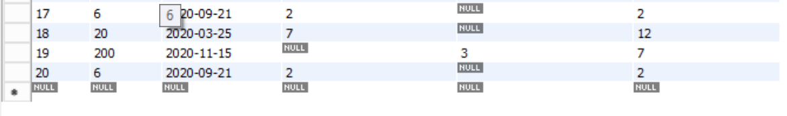

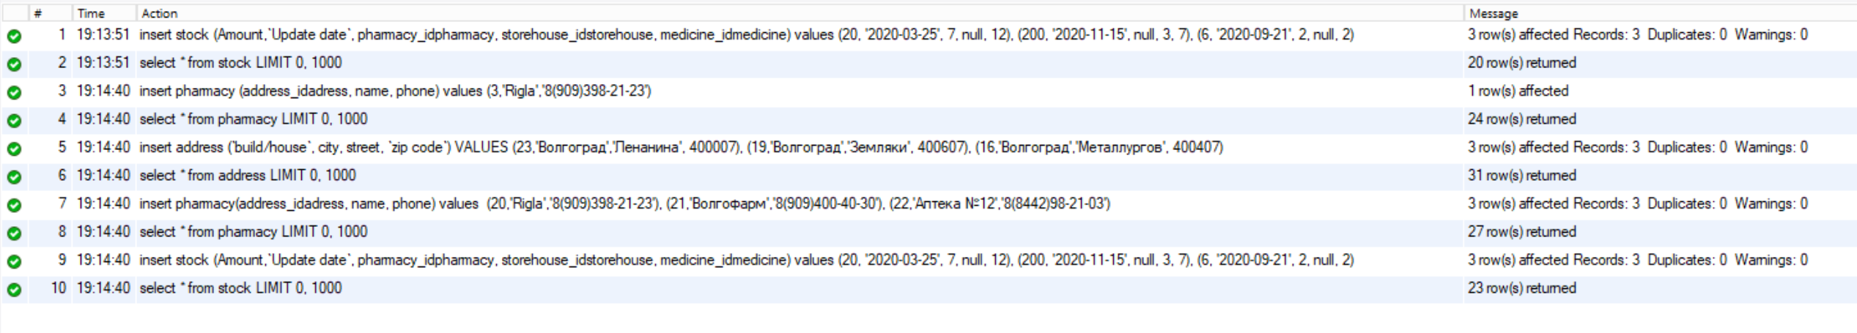

Запросы UPDATE (с WHERE)

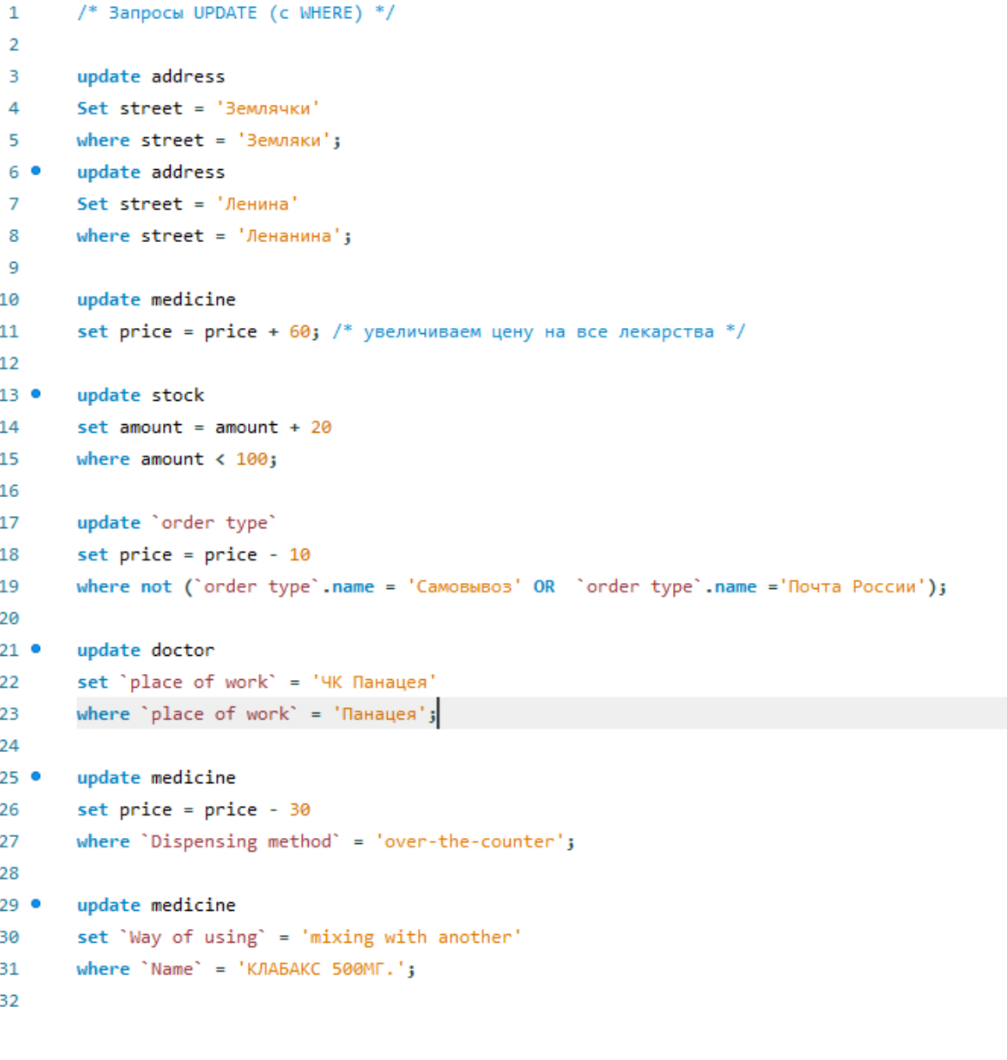

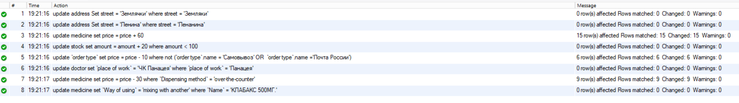

Запросы с Delete (с Where)

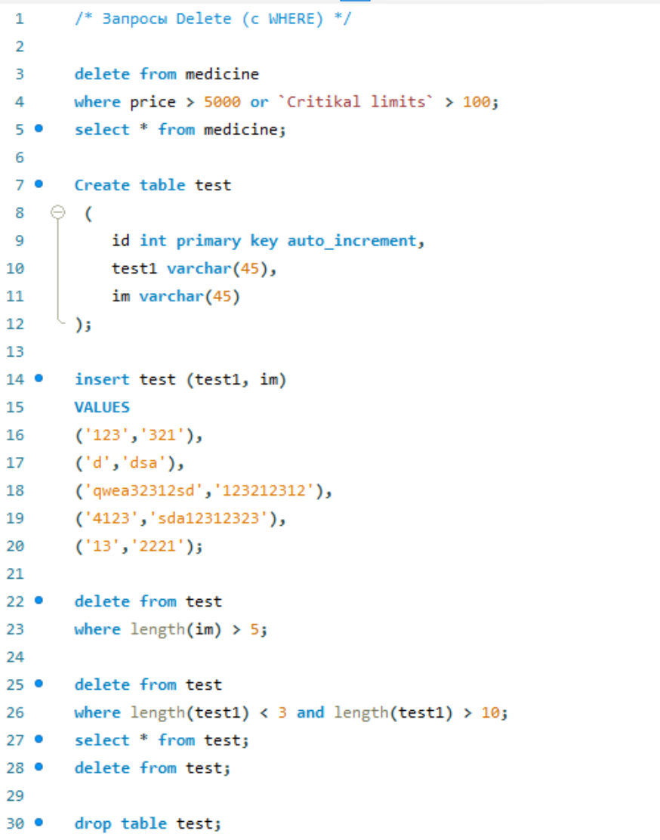

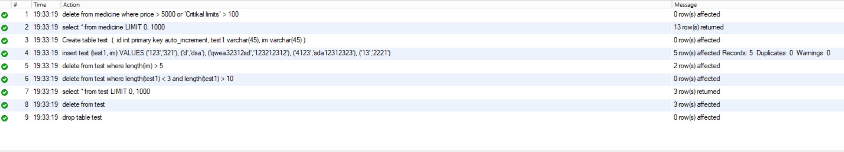

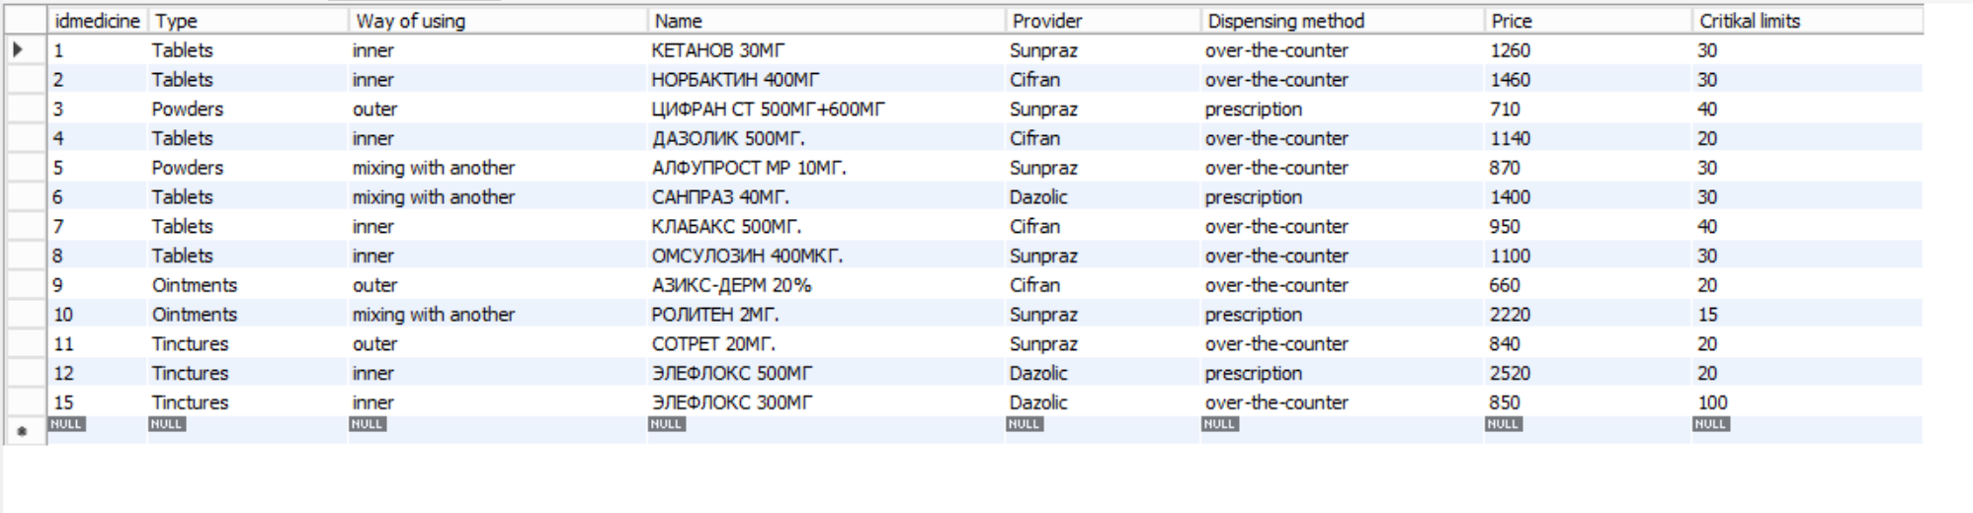

Запросы distinct(2), not(4), in(2), between, is null, as

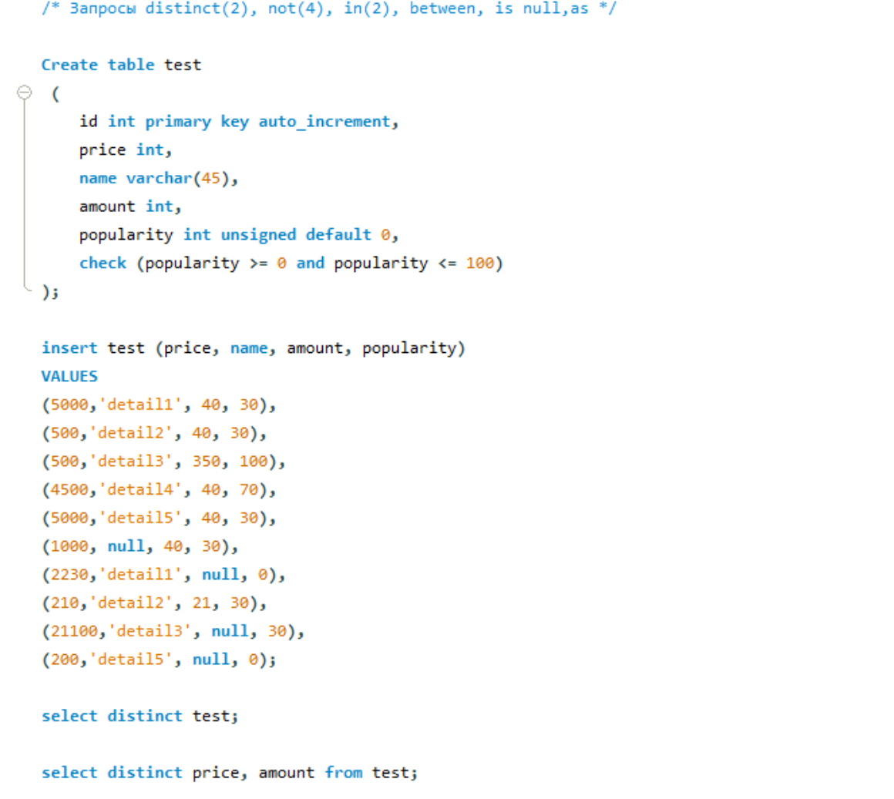



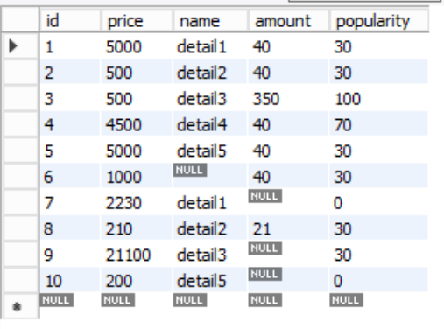 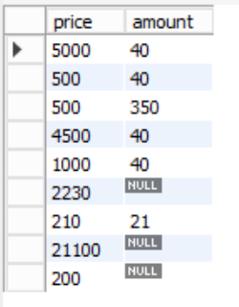

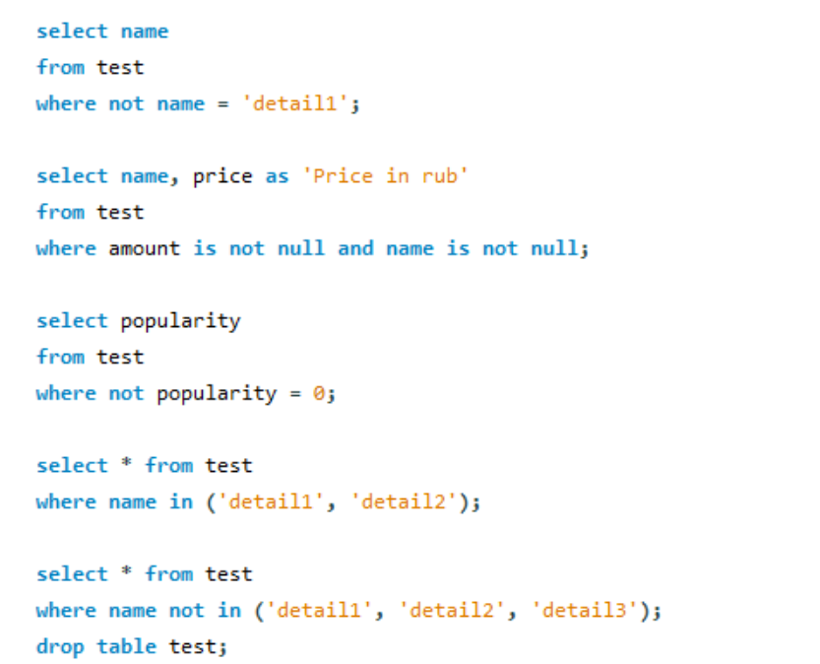

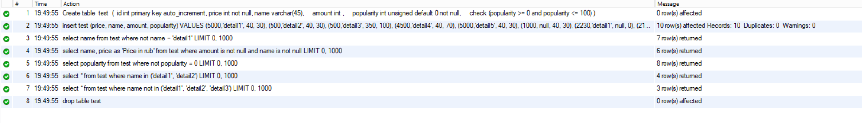

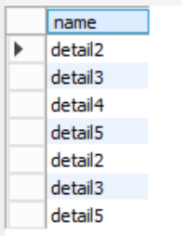 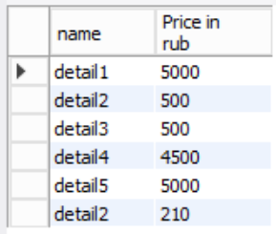 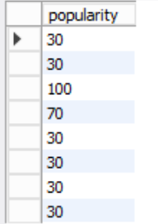 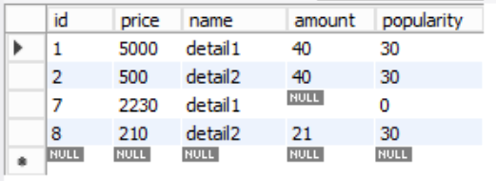

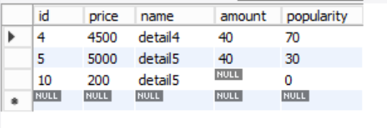

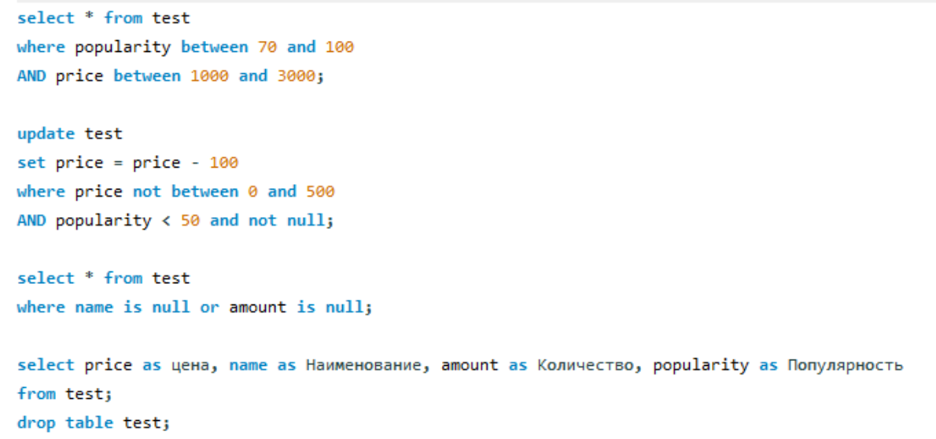

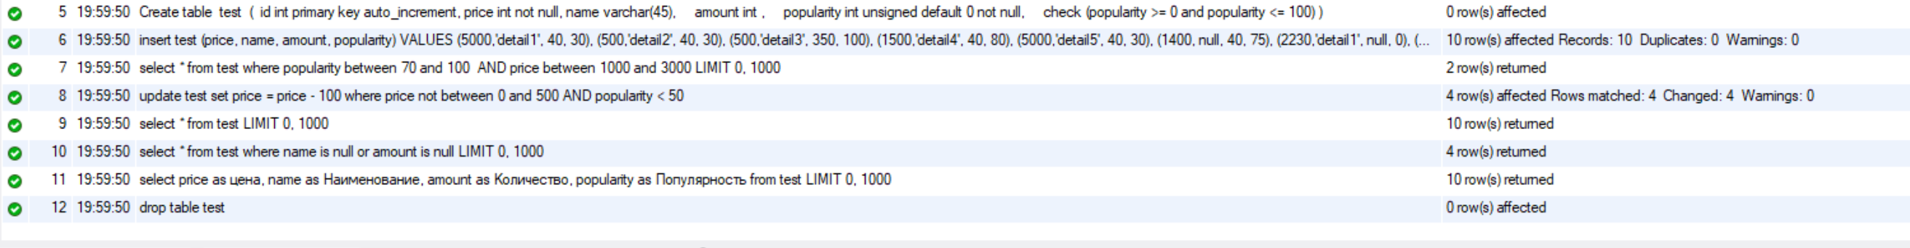

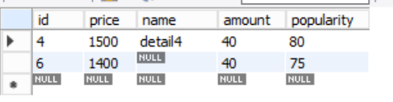

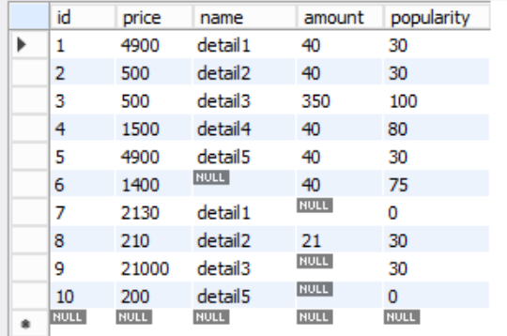

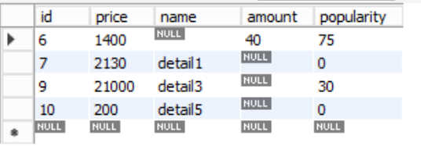

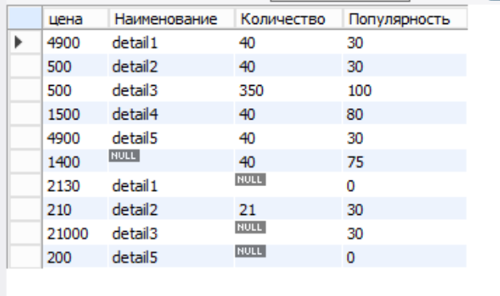

Запросы Like, REGEXP

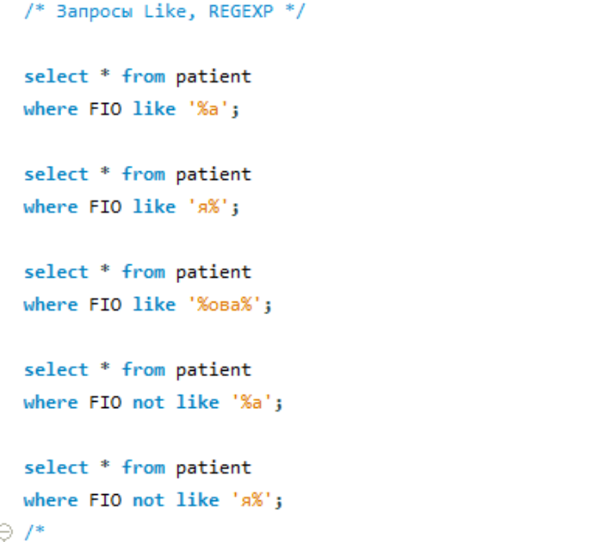

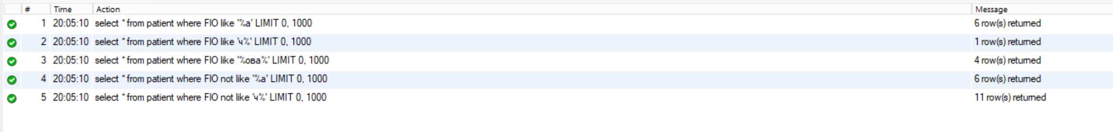

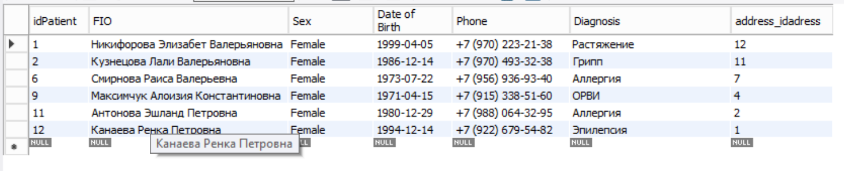



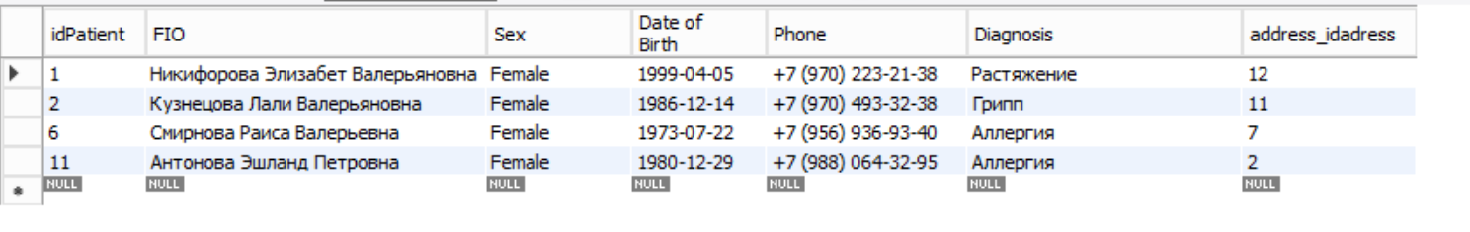

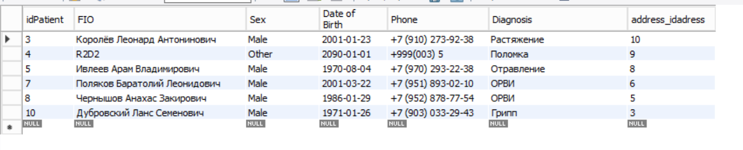



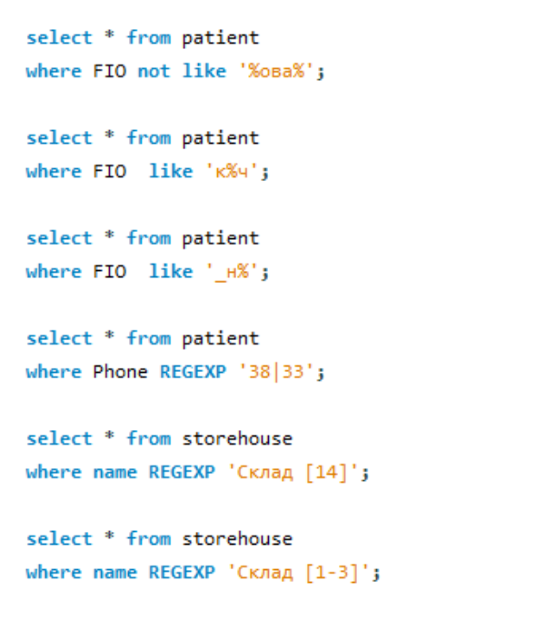

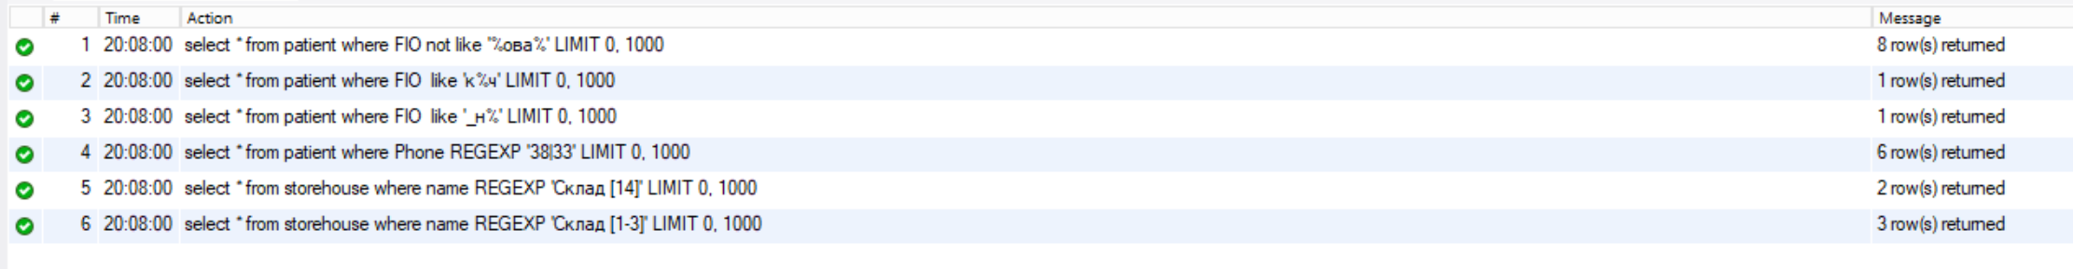

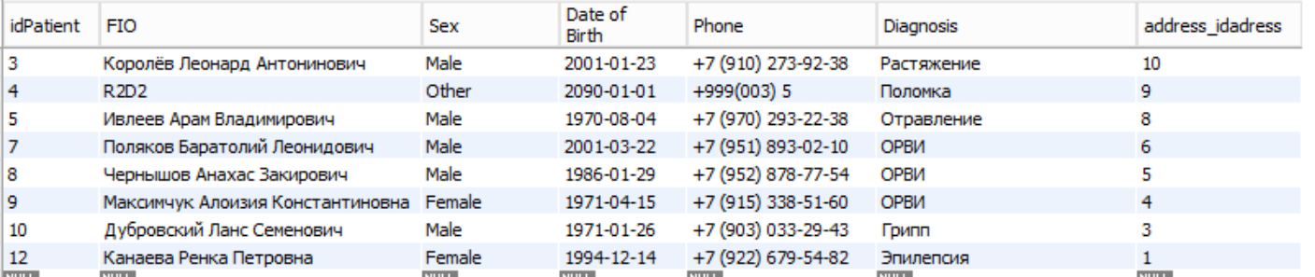





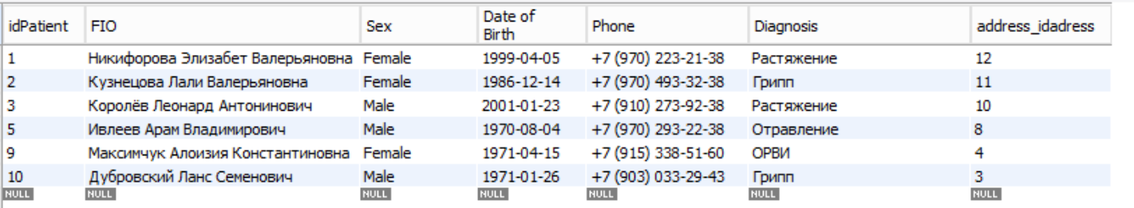

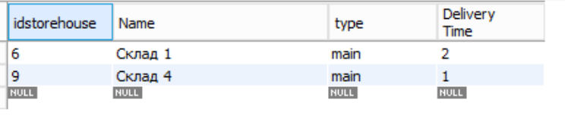

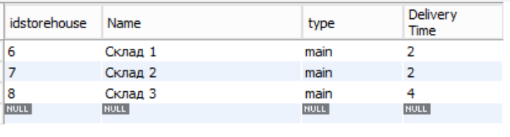

Запросы Count, max, min, sum, avg

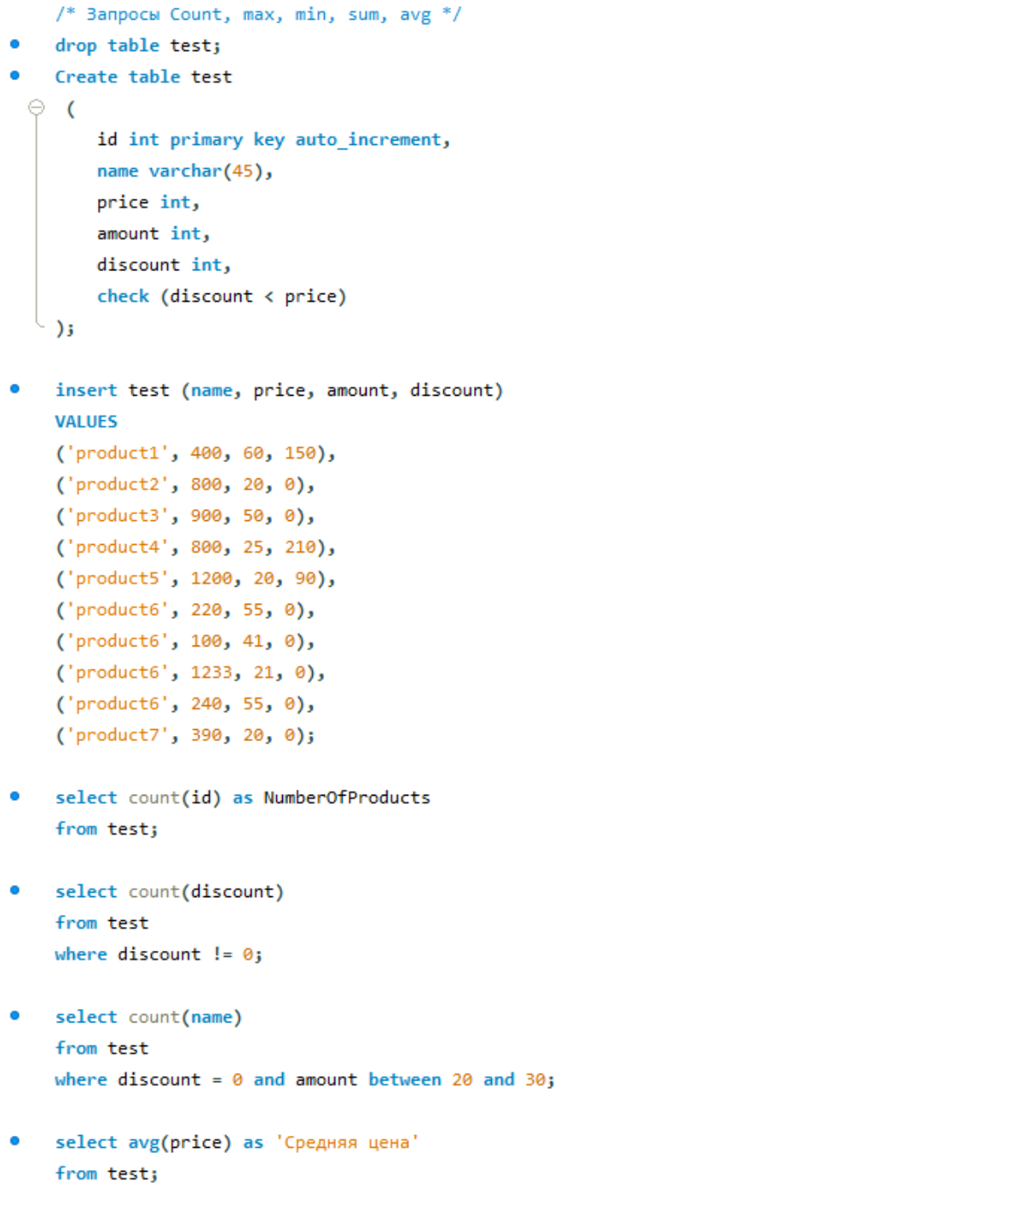

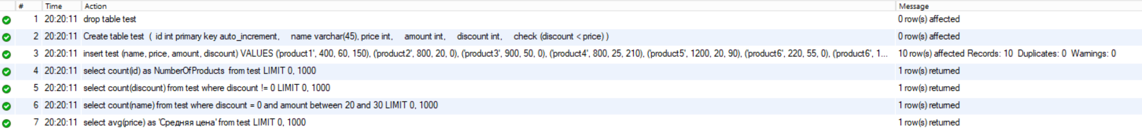

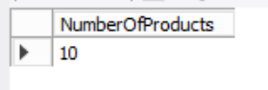 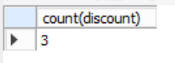 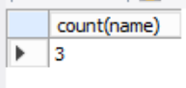 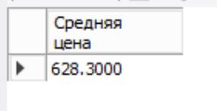

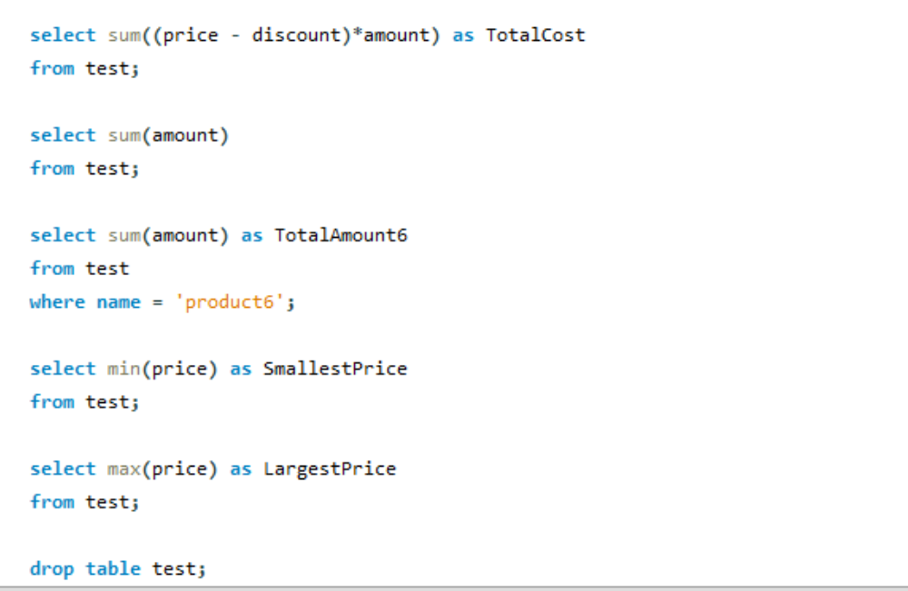

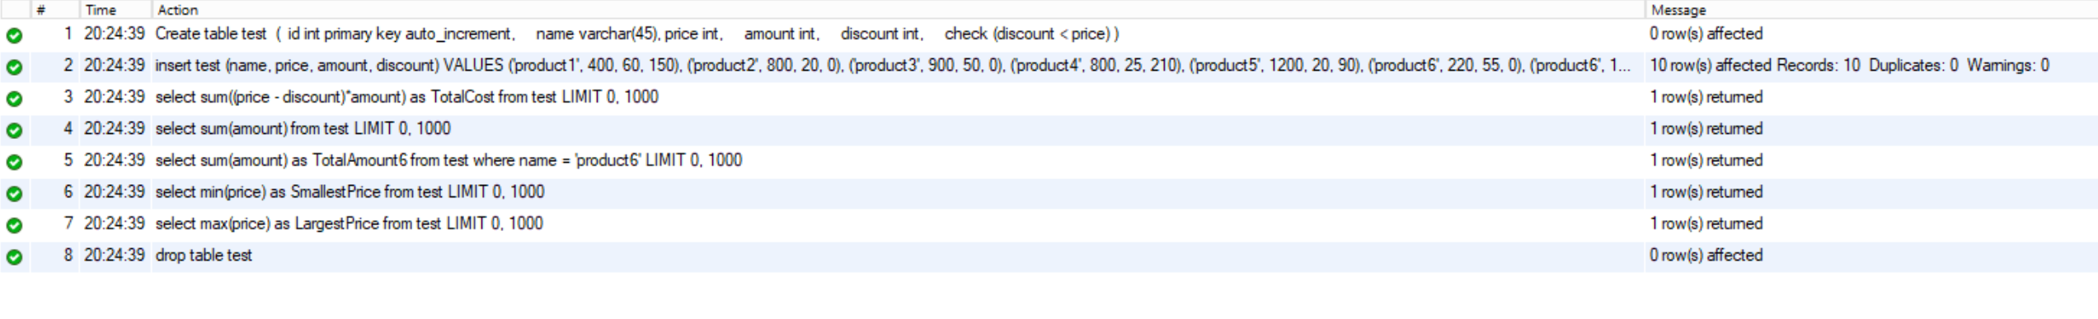

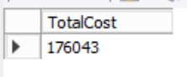 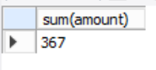 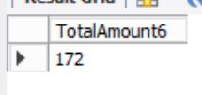 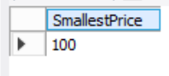 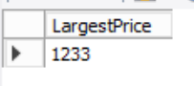

Запросы Group by, having

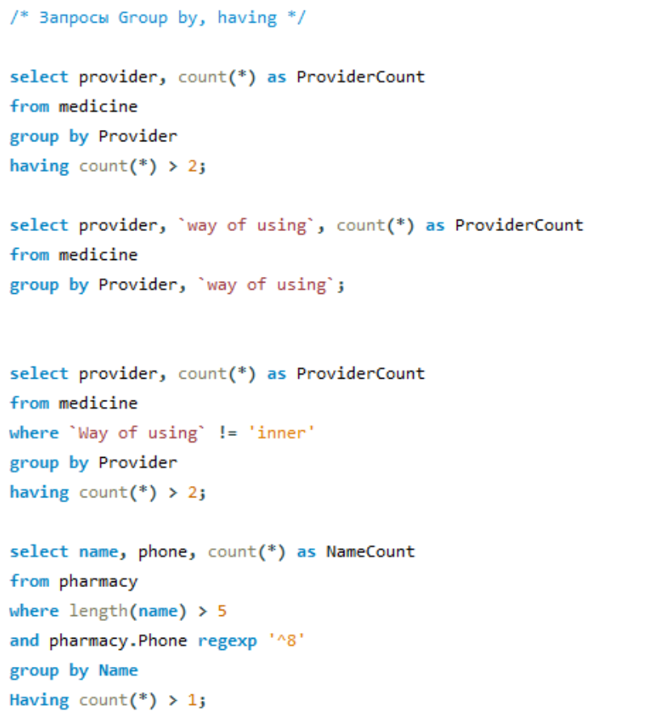



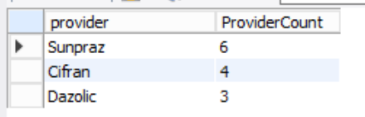

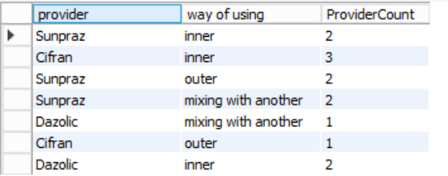

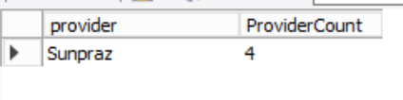

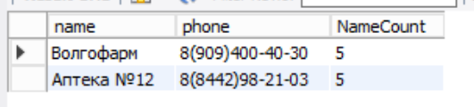

Запросы order by, ASC|DESC

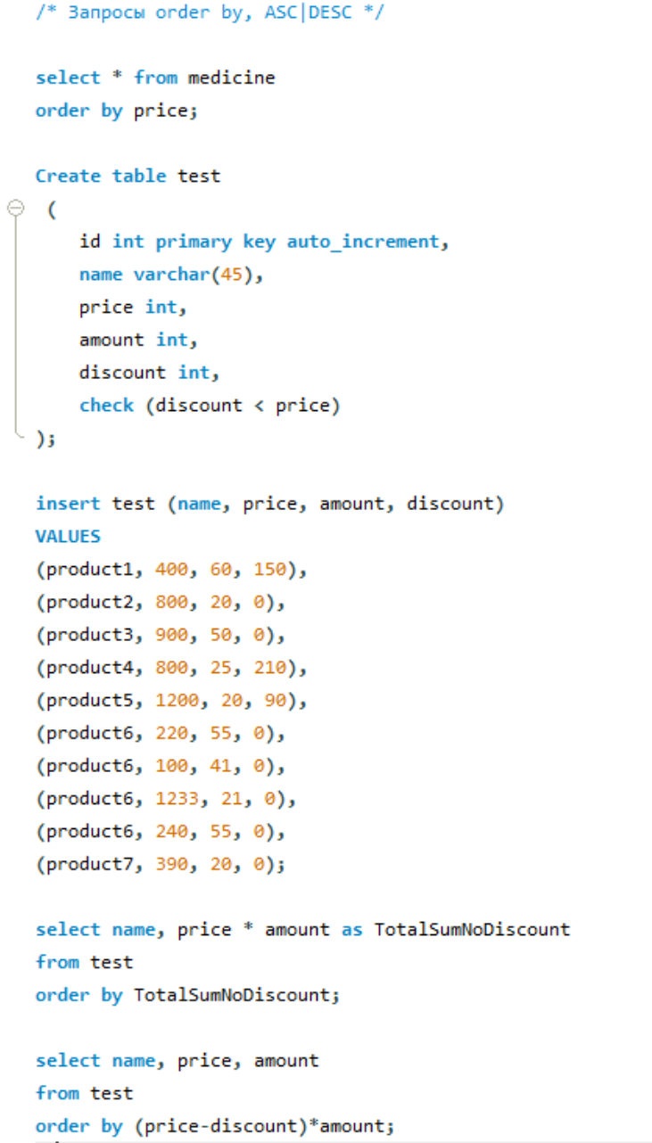

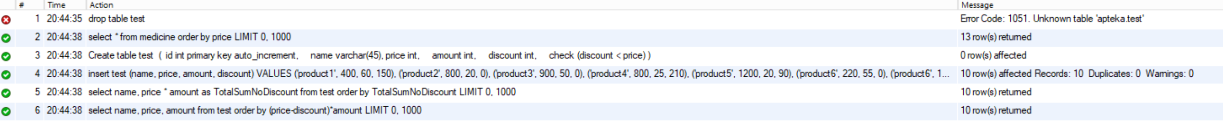

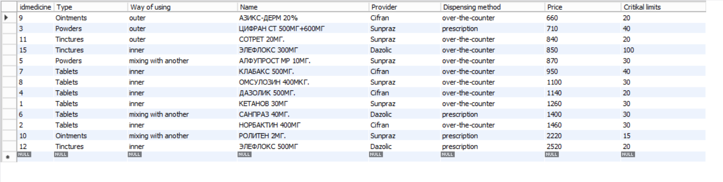

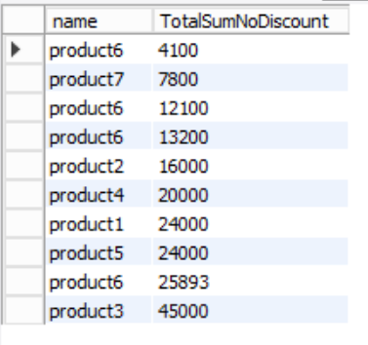 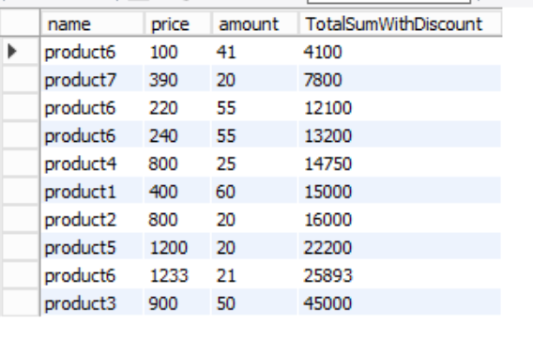

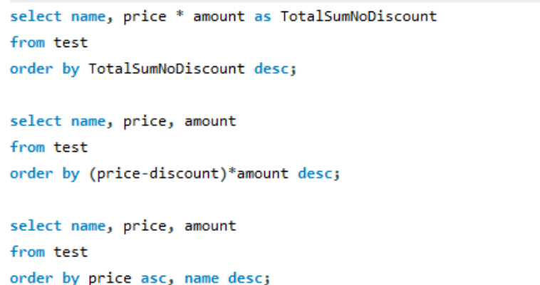



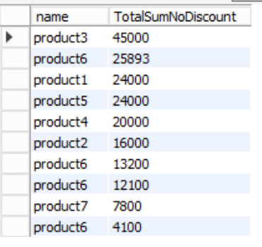

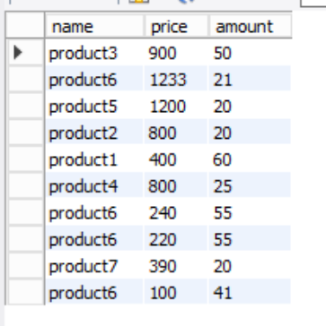

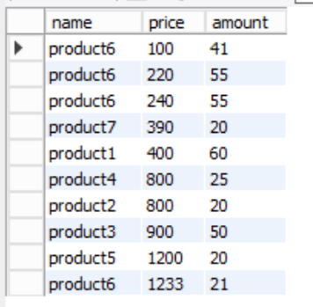

Вложенные select

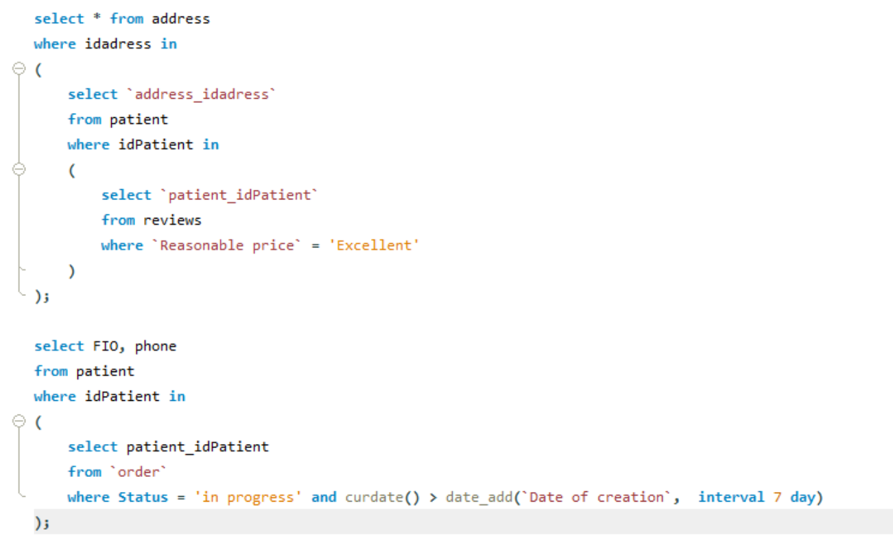



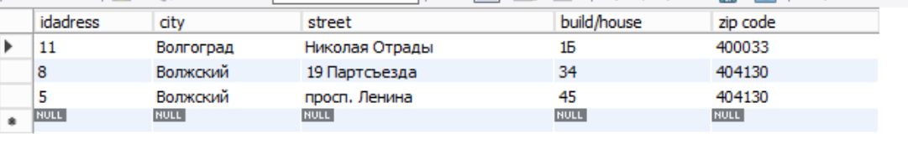

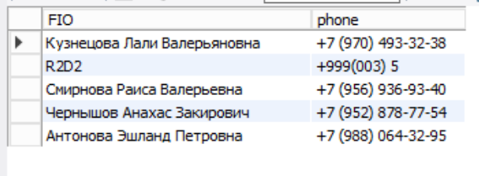

Запросы select into (не поддерживается заменил на что-то близкое)

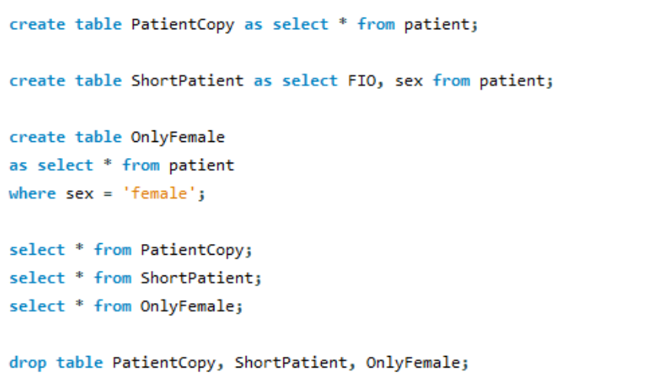

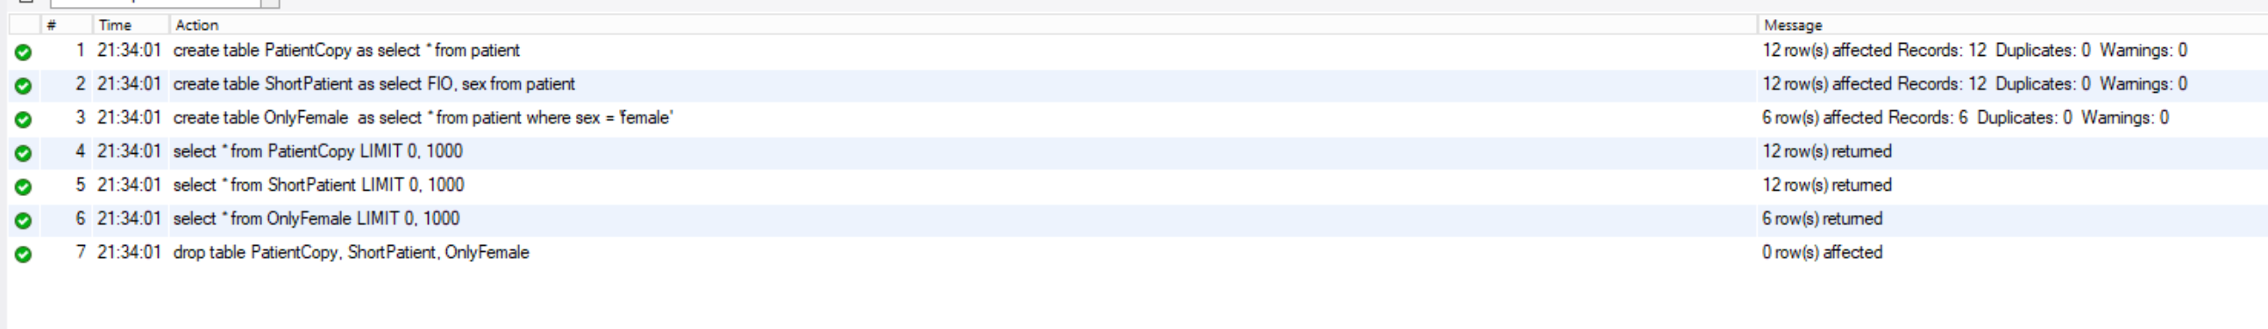

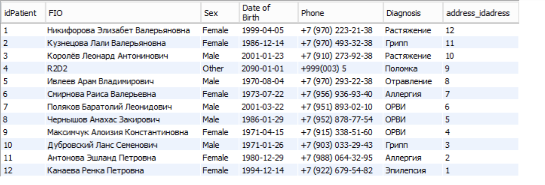

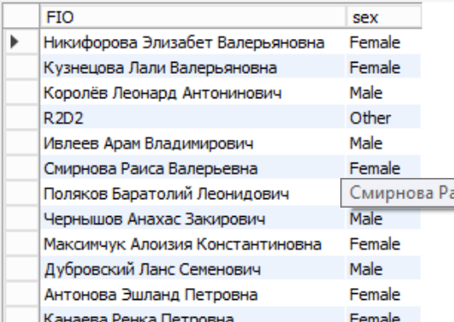

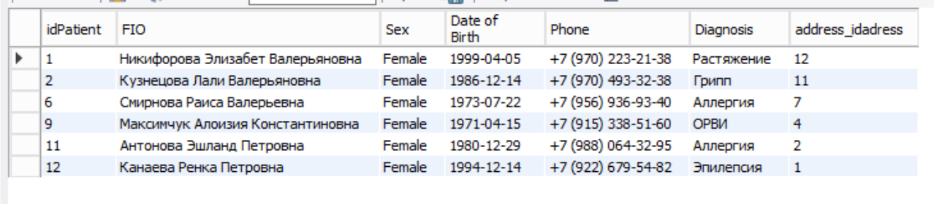

Запросы insert into select

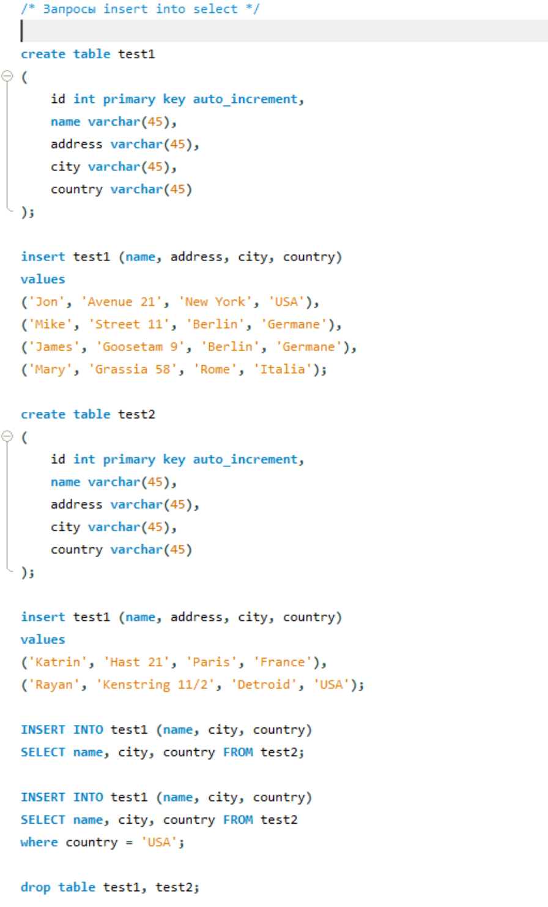

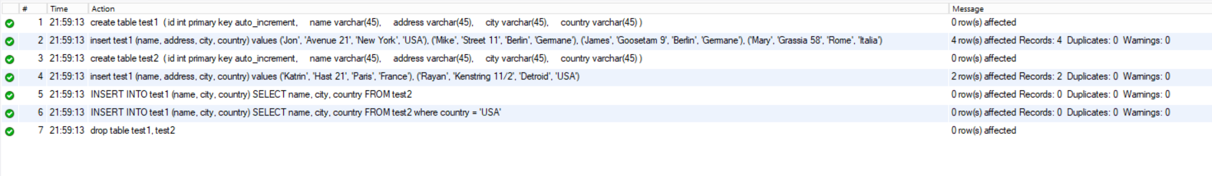

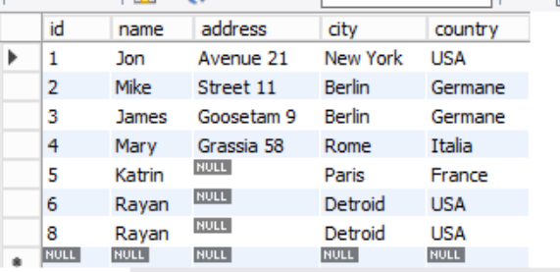 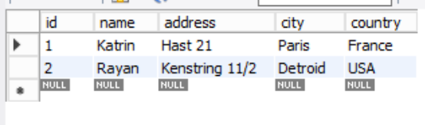

Запросы UNION (ALL), Except, Intercept

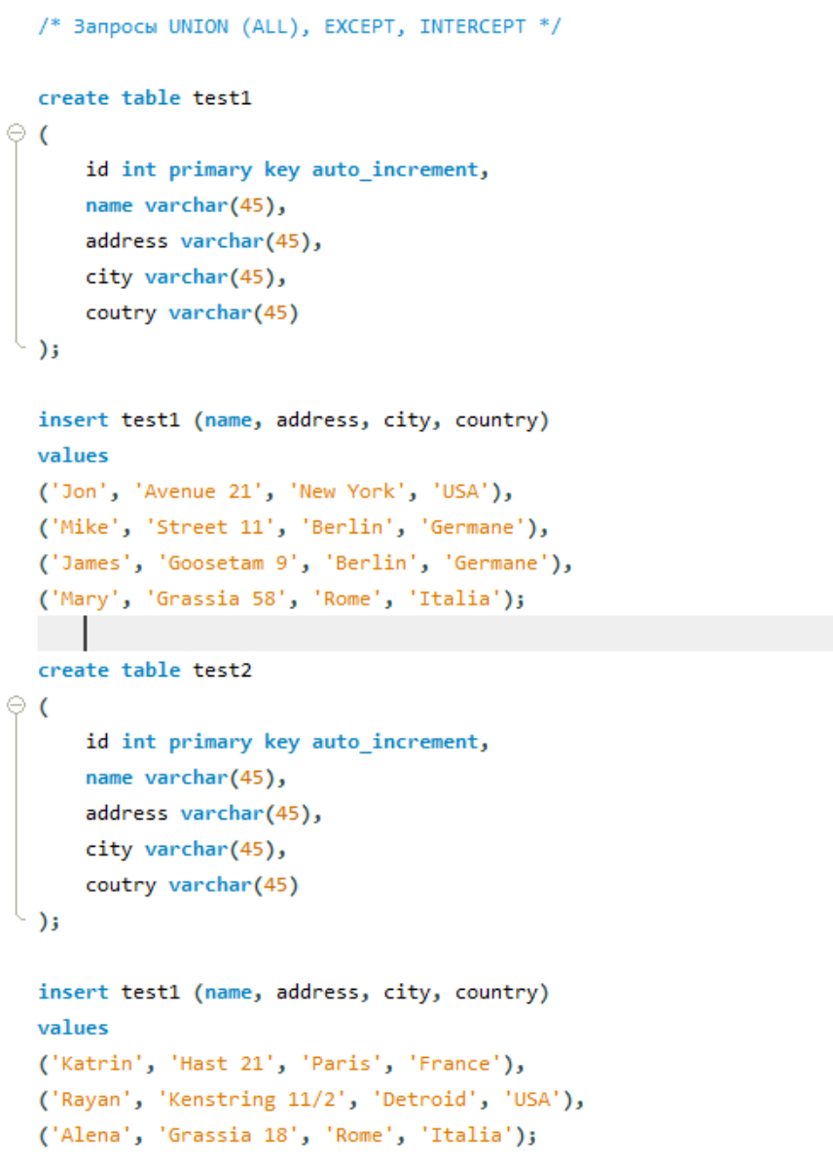

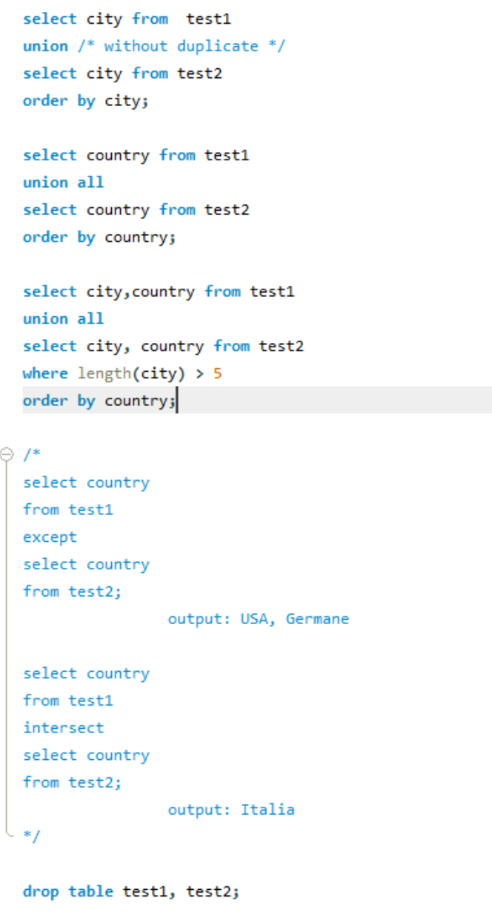

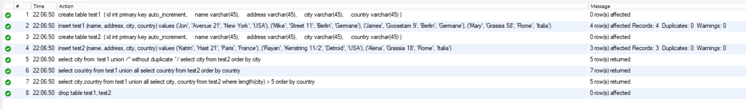

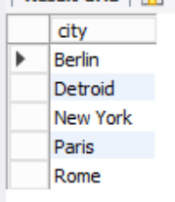

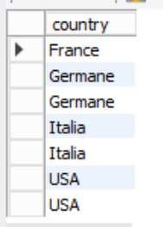

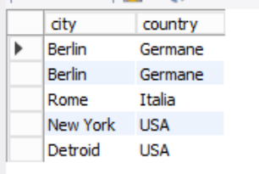

JOIN: INNER, OUTTER (LEFT, RIGHT, FULL), CROSS, NATURAL

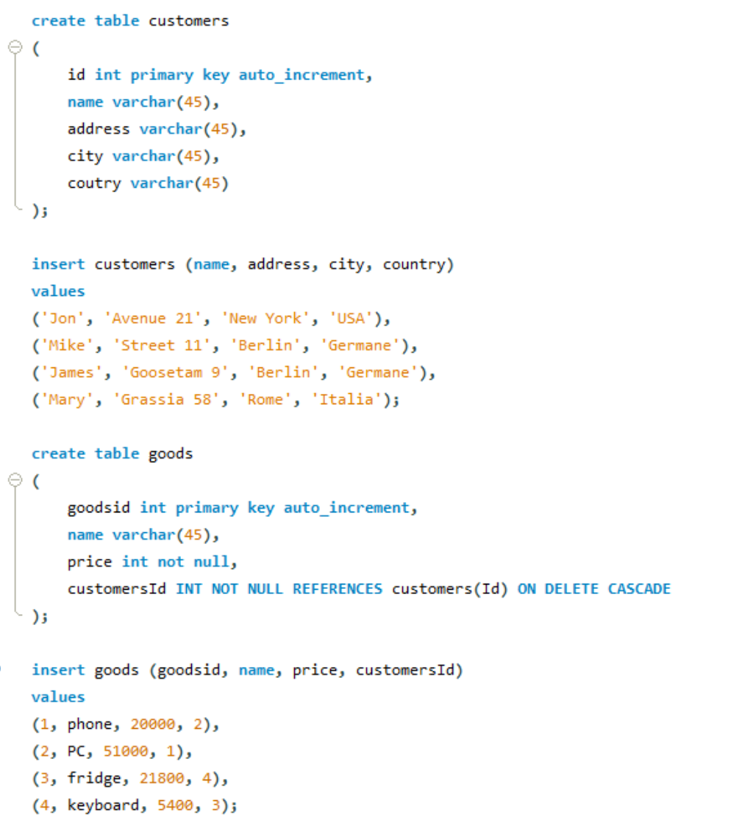

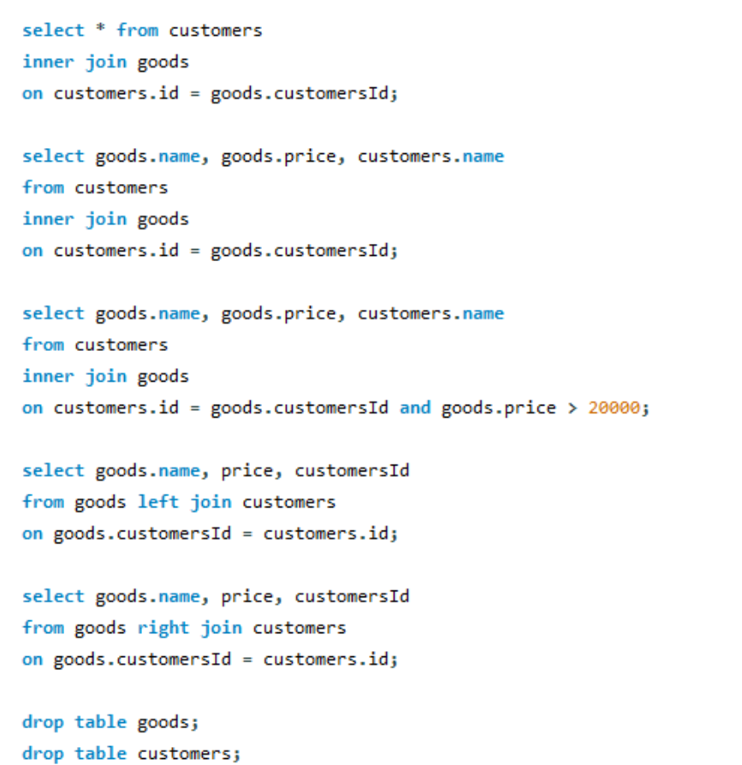

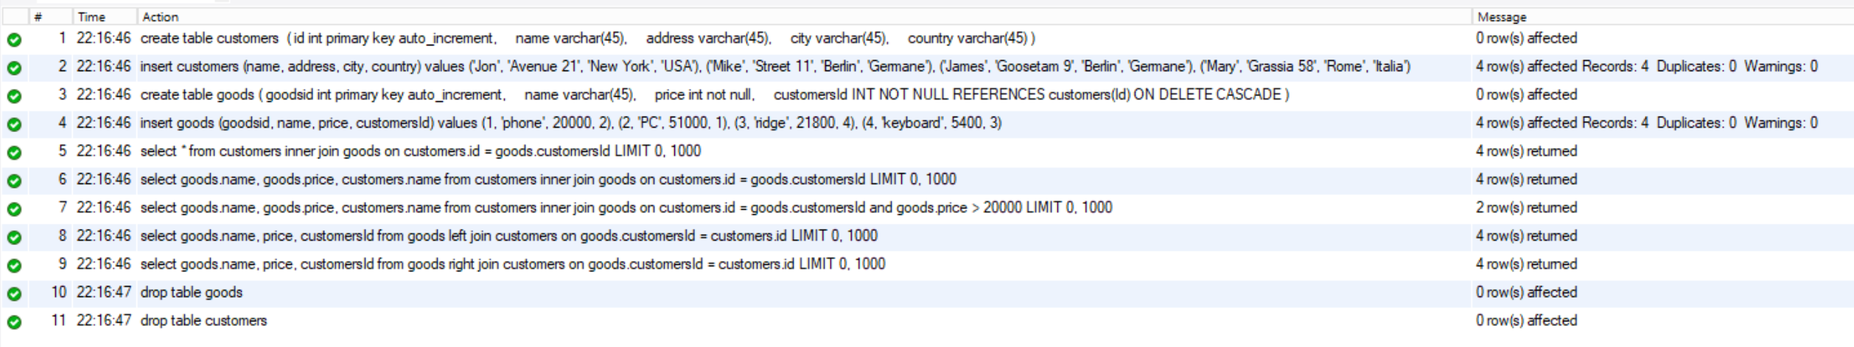

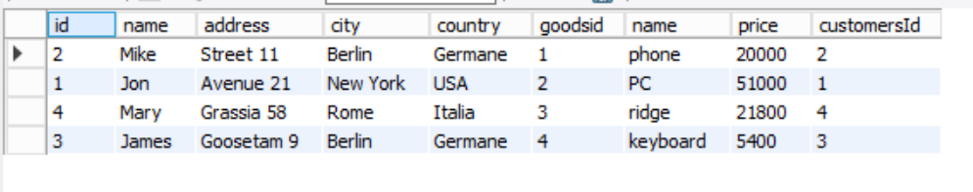

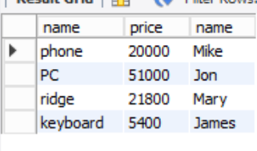

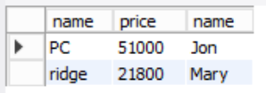

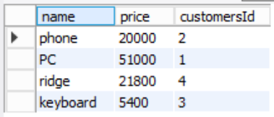

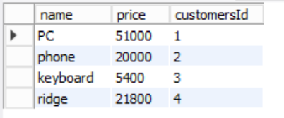

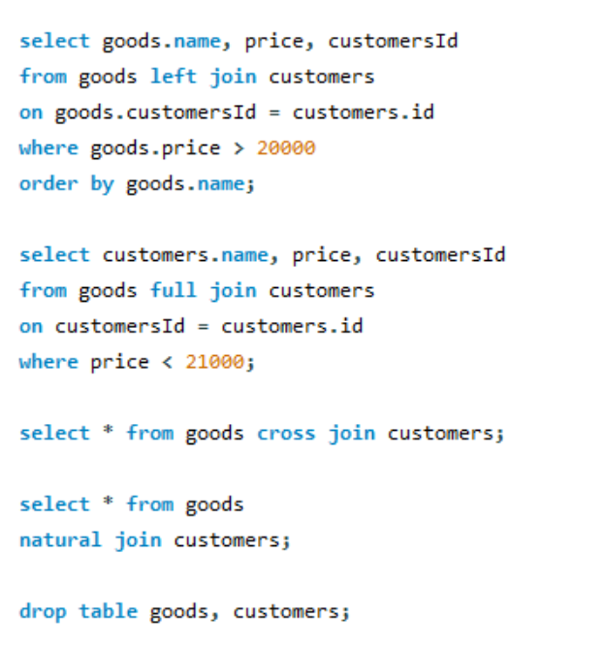

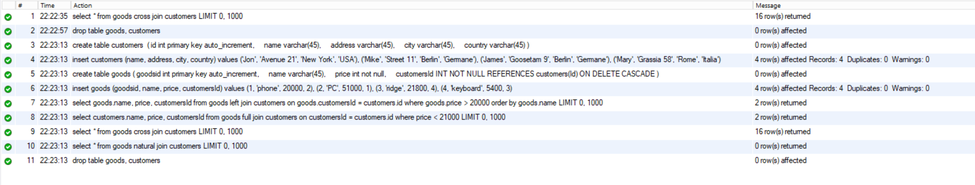

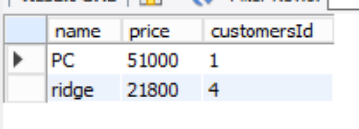

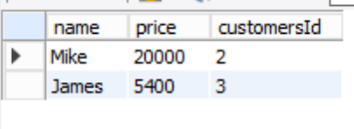

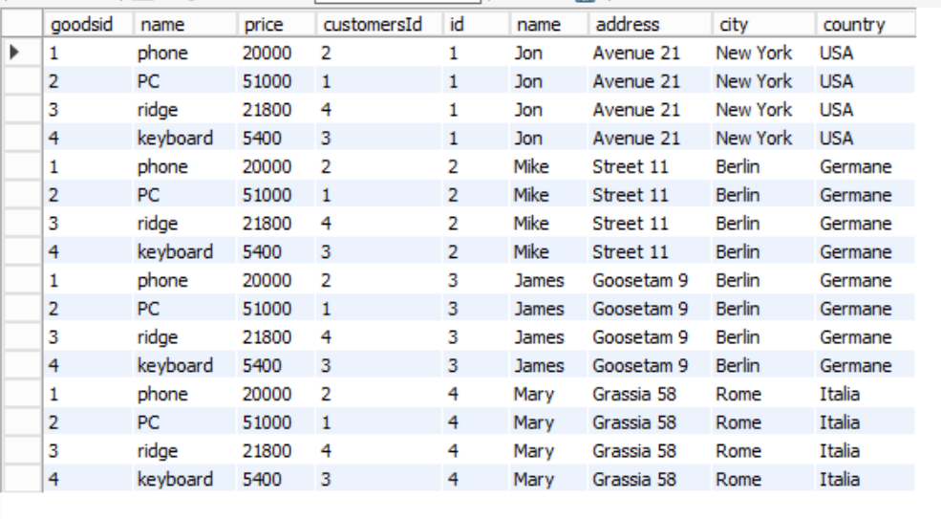

Limit

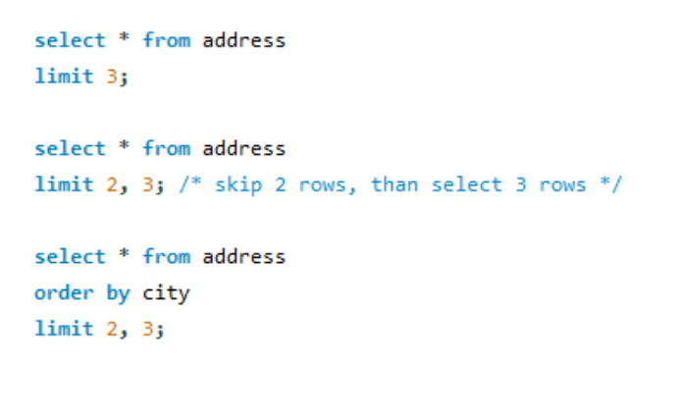

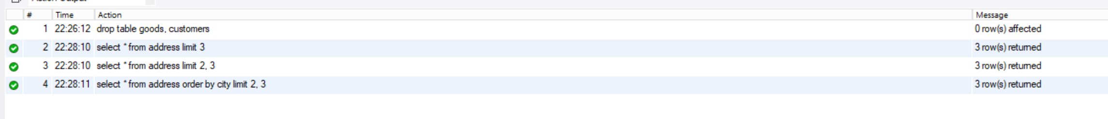

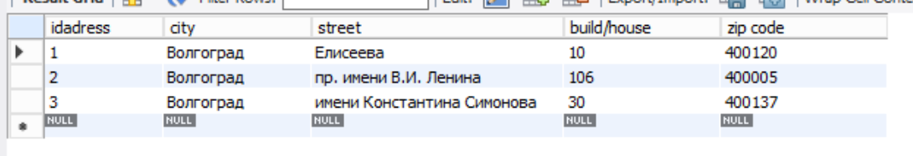

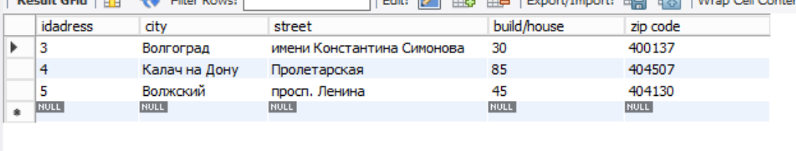

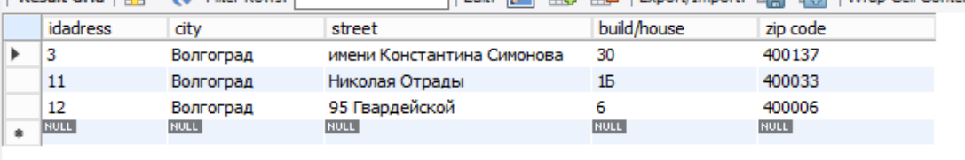

Полный код:

USE apteka;

/*Транзакционные (задачи учёта): */

/* Удалить отзыв */

delete from apteka.reviews

where idreviews = 8;

/* Изменить отзыв */

update reviews

set `Quality of service` = 'Excellent',

`Reasonable price` = 'Excellent',

`Delivery speed` = 'Excellent',

`Delivery quality` = 'Excellent',

`Wishes` = null

where idreviews = 12;

/* Отметить заказ */

delete from `order`

where idorder = 12;

/* Перенести планируемую дату доставки */

update storehouse

set `Delivery Time` = 3

where idstorehouse = 10;

/* Перенести адрес заказа */

update `order`

set `Delivery adress` = 'ул. Мелиоративная, 10, Светлый Яр, Волгоградская обл., 414161'

where idorder = 11;

/* Справочные (оперативные запросы): */

/* Получить перечень и типы лекарств, достигших своей критической нормы или закончившихся */

select `name`, provider, `type`

from medicine, stock

where medicine.idmedicine = stock.medicine_idmedicine

and stock.Amount < medicine.`Critikal limits`;

/* Получить перечень лекарств с минимальным запасом на складе в целом */

select `name`, provider, Amount

from medicine, stock

where stock.Amount = (select min(amount) from stock)

and medicine.idmedicine = stock.medicine_idmedicine;

/* Получить перечень лекарств с минимальным запасом на складе по указанной категории медикаментов */

select `name`, type, provider, Amount

from medicine, stock

where stock.Amount = (select min(amount) from stock)

and stock.medicine_idmedicine = medicine.idmedicine

and medicine.Type = 'Powders';

/* Получить полный перечень и общее число заказов, находящихся в производстве */

select amount, medicine.Name, medicine.Provider

from `order`, medicine, order_has_medicine

where `order`.status = 'in progress'

and `order`.idorder = order_has_medicine.order_idorder

and order_has_medicine.medicine_idmedicine = medicine.idmedicine

order by Amount;

/* Получить активные заказы в одной аптеке */

select `name`, city, street, `zip code`,`order`.Amount, `Date of creation`

from `order`, pharmacy, address

where `order`.Status = 'in progress'

and `order`.pharmacy_idpharmacy = pharmacy.idpharmacy

and pharmacy.address_idadress = address.idadress;

/* Справочные расчётные (аналитические запросы): */

/* Получить сведения о покупателях, которые не пришли забрать свой заказ в назначенное им время и их число */

select idPatient, FIO, Phone, `order`.status

from patient, `order`, storehouse

where patient.idPatient = `order`.patient_idPatient

and `order`.status = 'waiting'

and date_sub(current_date(), interval )

/* Получить перечень пяти наиболее часто используемых медикаментов в целом */

select medicine.name, type, Provider

from `order`, medicine

where pharmacy_idpharmacy = medicine.idmedicine

group by pharmacy_idpharmacy

order by count(*) desc

limit 5;

/* Получить сведения о трех клиентах сделавших самые большие заказы */

select FIO, Sex, phone, `order`.Amount

from patient, `order`

where `order`.patient_idPatient = patient.idPatient

group by `order`.Amount

order by `order`.Amount desc

limit 3;

/* Получить месячный объем продаж лекарств */

select sum(amount) as TotalAmount from `order`

where curdate() >= `order`.`Date of creation` and curdate() <= date_add(`order`.`Date of creation`, interval 1 month);

/* Получить среднюю стоимость лекарств, проданных за месяц */

select avg(amount * medicine.Price) as 'AveragePrice in rub' from `order`, medicine

where curdate() > `order`.`Date of creation` and curdate() < date_add(`order`.`Date of creation`, interval 1 month);

/* Запросы INSERT*/

insert pharmacy (address_idadress, name, phone)

values (3,'Rigla','8(909)398-21-23');

insert address (`build/house`, city, street, `zip code`)

VALUES

(23,'Волгоград','Ленанина', 400007),

(19,'Волгоград','Земляки', 400607),

(16,'Волгоград','Металлургов', 400407);

insert pharmacy(address_idadress, name, phone)

values

(20,'Rigla','8(909)398-21-23'),

(21,'Волгофарм','8(909)400-40-30'),

(22,'Аптека №12','8(8442)98-21-03');

insert stock (Amount,`Update date`, pharmacy_idpharmacy, storehouse_idstorehouse, medicine_idmedicine)

values

(20, '2020-03-25', 7, null, 12),

(200, '2020-11-15', null, 3, 7),

(6, '2020-09-21', 2, null, 2);

/* Запросы UPDATE (с WHERE) */

update address

Set street = 'Землячки'

where street = 'Земляки';

update address

Set street = 'Ленина'

where street = 'Ленанина';

update medicine

set price = price + 60; /* увеличиваем цену на все лекарства */

update stock

set amount = amount + 20

where amount < 100;

update `order type`

set price = price - 10

where not (`order type`.name = 'Самовывоз' OR `order type`.name ='Почта России');

update doctor

set `place of work` = 'ЧК Панацея'

where `place of work` = 'Панацея';

update medicine

set price = price - 30

where `Dispensing method` = 'over-the-counter';

update medicine

set `Way of using` = 'mixing with another'

where `Name` = 'КЛАБАКС 500МГ.';

/* Запросы Delete (с WHERE) */

delete from medicine

where price > 5000 or `Critikal limits` > 100;

Create table test

(

id int primary key auto_increment,

test1 varchar(45),

im varchar(45)

);

insert test (test1, im)

VALUES

('123','321'),

('d','dsa'),

('qwea32312sd','123212312'),

('4123','sda12312323'),

('13','2221');

delete from test

where length(im) > 5;

delete from test

where length(test1) < 3 and length(test1) > 10;

delete from test;

drop table test;

/* Запросы distinct(2), not(4), in(2), between, is null,as */

Create table test

(

id int primary key auto_increment,

price int,

name varchar(45),

amount int,

popularity int unsigned default 0,

check (popularity >= 0 and popularity <= 100)

);

insert test (price, name, amount, popularity)

VALUES

(5000,'detail1', 40, 30),

(500,'detail2', 40, 30),

(500,'detail3', 350, 100),

(1500,'detail4', 40, 80),

(5000,'detail5', 40, 30),

(1400, null, 40, 75),

(2230,'detail1', null, 0),

(210,'detail2', 21, 30),

(21100,'detail3', null, 30),

(200,'detail5', null, 0);

select distinct * from test;

select distinct price, amount from test;

select name

from test

where not name = 'detail1';

select name, price as 'Price in rub'

from test

where amount is not null and name is not null;

select popularity

from test

where not popularity = 0;

select * from test

where name in ('detail1', 'detail2');

select * from test

where name not in ('detail1', 'detail2', 'detail3');

select * from test

where popularity between 70 and 100

AND price between 1000 and 3000;

update test

set price = price - 100

where price not between 0 and 500

AND popularity < 50;

select * from test

where name is null or amount is null;

select price as цена, name as Наименование, amount as Количество, popularity as Популярность

from test;

drop table test;

/* Запросы Like, REGEXP */

select * from patient

where FIO like '%а';

select * from patient

where FIO like 'ч%';

select * from patient

where FIO like '%ова%';

select * from patient

where FIO not like '%а';

select * from patient

where FIO not like 'ч%';

select * from patient

where FIO not like '%ова%';

select * from patient

where FIO like 'к%ч';

select * from patient

where FIO like '_н%';

select * from patient

where Phone REGEXP '38|33';

select * from storehouse

where name REGEXP 'Склад [14]';

select * from storehouse

where name REGEXP 'Склад [1-3]';

/* Запросы Сount, max, min, sum, avg */

Create table test

(

id int primary key auto_increment,

name varchar(45),

price int,

amount int,

discount int,

check (discount < price)

);

insert test (name, price, amount, discount)

VALUES

('product1', 400, 60, 150),

('product2', 800, 20, 0),

('product3', 900, 50, 0),

('product4', 800, 25, 210),

('product5', 1200, 20, 90),

('product6', 220, 55, 0),

('product6', 100, 41, 0),

('product6', 1233, 21, 0),

('product6', 240, 55, 0),

('product7', 390, 20, 0);

select count(id) as NumberOfProducts

from test;

select count(discount)

from test

where discount != 0;

select count(name)

from test

where discount = 0 and amount between 20 and 30;

select avg(price) as 'Средняя цена'

from test;

select sum((price - discount)*amount) as TotalCost

from test;

select sum(amount)

from test;

select sum(amount) as TotalAmount6

from test

where name = 'product6';

select min(price) as SmallestPrice

from test;

select max(price) as LargestPrice

from test;

drop table test;

/* Запросы Group by, having */

select provider, count(*) as ProviderCount

from medicine

group by Provider

having count(*) > 2;

select provider, `way of using`, count(*) as ProviderCount

from medicine

group by Provider, `way of using`;

select provider, count(*) as ProviderCount

from medicine

where `Way of using` != 'inner'

group by Provider

having count(*) > 2;

select name, phone, count(*) as NameCount

from pharmacy

where length(name) > 5

and pharmacy.Phone regexp '^8'

group by Name

Having count(*) > 1;

/* Запросы order by, ASC|DESC */

select * from medicine

order by price;

Create table test

(

id int primary key auto_increment,

name varchar(45),

price int,

amount int,

discount int,

check (discount < price)

);

insert test (name, price, amount, discount)

VALUES

('product1', 400, 60, 150),

('product2', 800, 20, 0),

('product3', 900, 50, 0),

('product4', 800, 25, 210),

('product5', 1200, 20, 90),

('product6', 220, 55, 0),

('product6', 100, 41, 0),

('product6', 1233, 21, 0),

('product6', 240, 55, 0),

('product7', 390, 20, 0);

select name, price * amount as TotalSumNoDiscount

from test

order by TotalSumNoDiscount;

select name, price, amount, (price-discount)*amount as TotalSumWithDiscount

from test

order by (price-discount)*amount;

select name, price * amount as TotalSumNoDiscount

from test

order by TotalSumNoDiscount desc;

select name, price, amount

from test

order by (price-discount)*amount desc;

select name, price, amount

from test

order by price asc, name desc;

drop table test;

/* Вложенные select */

select * from address

where idadress in

(

select `address_idadress`

from patient

where idPatient in

(

select `patient_idPatient`

from reviews

where `Reasonable price` = 'Excellent'

)

);

select FIO, phone

from patient

where idPatient in

(

select patient_idPatient

from `order`

where Status = 'in progress' and curdate() > date_add(`Date of creation`, interval 7 day)

);

/* Запросы select into

select * into PatientCopy

from patient;

select FIO, sex into ShortPatient

from patient;

select * into OnlyFemale

from patient

where sex = 'female';

select patient.FIO, `order`.idorder

into test1

from patient,order

left join `order` on patient.patientid = `order.patientid`;

drop table PatientCopy, ShortPatient, OnlyFemale, test1; */

create table PatientCopy as select * from patient;

create table ShortPatient as select FIO, sex from patient;

create table OnlyFemale

as select * from patient

where sex = 'female';

select * from PatientCopy;

select * from ShortPatient;

select * from OnlyFemale;

drop table PatientCopy, ShortPatient, OnlyFemale;

/* Запросы insert into select */

create table test1

(

id int primary key auto_increment,

name varchar(45),

address varchar(45),

city varchar(45),

country varchar(45)

);

insert test1 (name, address, city, country)

values

('Jon', 'Avenue 21', 'New York', 'USA'),

('Mike', 'Street 11', 'Berlin', 'Germane'),

('James', 'Goosetam 9', 'Berlin', 'Germane'),

('Mary', 'Grassia 58', 'Rome', 'Italia');

create table test2

(

id int primary key auto_increment,

name varchar(45),

address varchar(45),

city varchar(45),

country varchar(45)

);

insert test2 (name, address, city, country)

values

('Katrin', 'Hast 21', 'Paris', 'France'),

('Rayan', 'Kenstring 11/2', 'Detroid', 'USA');

INSERT INTO test1 (name, city, country)

SELECT name, city, country FROM test2;

INSERT INTO test1 (name, city, country)

SELECT name, city, country FROM test2

where country = 'USA';

drop table test1, test2;

/* Запросы UNION (ALL), EXCEPT, INTERCEPT */

create table test1

(

id int primary key auto_increment,

name varchar(45),

address varchar(45),

city varchar(45),

country varchar(45)

);

insert test1 (name, address, city, country)

values

('Jon', 'Avenue 21', 'New York', 'USA'),

('Mike', 'Street 11', 'Berlin', 'Germane'),

('James', 'Goosetam 9', 'Berlin', 'Germane'),

('Mary', 'Grassia 58', 'Rome', 'Italia');

create table test2

(

id int primary key auto_increment,

name varchar(45),

address varchar(45),

city varchar(45),

country varchar(45)

);

insert test2 (name, address, city, country)

values

('Katrin', 'Hast 21', 'Paris', 'France'),

('Rayan', 'Kenstring 11/2', 'Detroid', 'USA'),

('Alena', 'Grassia 18', 'Rome', 'Italia');

select city from test1

union /* without duplicate */

select city from test2

order by city;

select country from test1

union all

select country from test2

order by country;

select city,country from test1

union all

select city, country from test2

where length(city) > 5

order by country;

/*

select country

from test1

except

select country

from test2;

output: USA, Germane

select country

from test1

intersect

select country

from test2;

output: Italia

*/

drop table test1, test2;

/* JOIN: INNER, OUTTER (LEFT, RIGHT, FULL), CROSS, NATURAL */

/* JOIN: INNER, OUTTER (LEFT, RIGHT, FULL), CROSS, NATURAL */

create table customers

(

id int primary key auto_increment,

name varchar(45),

address varchar(45),

city varchar(45),

country varchar(45)

);

insert customers (name, address, city, country)

values

('Jon', 'Avenue 21', 'New York', 'USA'),

('Mike', 'Street 11', 'Berlin', 'Germane'),

('James', 'Goosetam 9', 'Berlin', 'Germane'),

('Mary', 'Grassia 58', 'Rome', 'Italia');

create table goods

(

goodsid int primary key auto_increment,

name varchar(45),

price int not null,

customersId INT NOT NULL REFERENCES customers(Id) ON DELETE CASCADE

);

insert goods (goodsid, name, price, customersId)

values

(1, 'phone', 20000, 2),

(2, 'PC', 51000, 1),

(3, 'ridge', 21800, 4),

(4, 'keyboard', 5400, 3);

select * from customers

inner join goods

on customers.id = goods.customersId;

select goods.name, goods.price, customers.name

from customers

inner join goods

on customers.id = goods.customersId;

select goods.name, goods.price, customers.name

from customers

inner join goods

on customers.id = goods.customersId and goods.price > 20000;

select goods.name, price, customersId

from goods left join customers

on goods.customersId = customers.id;

select goods.name, price, customersId

from goods right join customers

on goods.customersId = customers.id;

select goods.name, price, customersId

from goods left join customers

on goods.customersId = customers.id

where goods.price > 20000

order by goods.name;

select customers.name, price, customersId

from goods full join customers

on customersId = customers.id

where price < 21000;

select * from goods cross join customers;

select * from goods

natural join customers;

drop table goods, customers;

/* Limit */

select * from address

limit 3;

select * from address

limit 2, 3; /* skip 2 rows, than select 3 rows */

select * from address

order by city

limit 2, 3;